REAL ESTATE APPRAISAL
OF
“Atria Cranford”
A Senior Living Facility
10 Jackson Drive
Township of Cranford
Union County, New Jersey
AAI
APPRAISAL ASSOCIATES, INC.
REAL ESTATE APPRAISERS AND CONSULTANTS

JOSEPH E. BALDONI, MAI
PRESIDENT
Member: APPRAISAL INSTITUTE
February 5, 2007
Mr. Peter Barnett, Tax Assessor
TOWNSHIP OF CRANFORD
8 Springfield Avenue
Cranford, New Jersey 07016
Re: Real Estate Appraisal
Atria Senior Living Facility
10 Jackson Drive
Township of Cranford
Union County, New Jersey
Block 644, Lot 1.01, Qual. C01
Dear Mr. Barnett:

As per your request, we are pleased to submit the following “Self-Contained” real estate appraisal report on the above-captioned property. The purpose of the appraisal is to estimate the property’s Market Value, to assist in establishing a fair and equitable real estate tax assessment.

A complete inspection of the property was performed, as well as an investigation and analysis of pertinent data affecting the value of the subject property. This appraisal employs generally accepted appraisal practices as set forth in the Uniform Standards of Professional Appraisal Practice.

Contained in the following report, of which this letter is a part, is a complete description of the property, the methods of approach, an analysis of the data gathered and the reasoning and conclusions reached. After careful consideration, we have concluded that the “As Is” Market Value of the subject property, as of October 1, 2004 and October 1, 2005 is:

October 1, 2004
TWENTY EIGHT MILLION EIGHT HUNDRED THOUSAND DOLLARS
($28,800,000)

October 1, 2005
TWENTY EIGHT MILLION EIGHT HUNDRED THOUSAND DOLLARS
($28,800,000)

Respectfully submitted,

APPRAISAL ASSOCIATES, INC.

Joseph C. Baldoni, SCGREA 1977 Joseph E. Baldoni, MAI, SCGREA 339
Vice President President
TABLE OF CONTENTS

Letter of Transmittal
Summary ii
General Location Map iii
Aerial Map iv
Subject Photographs v
Scope of the Assignment viii
Contingent and Limiting Conditions ix
Appraisal Process 1
Market Value Definition 2
Purpose of the Appraisal 3
Function of the Appraisal 3
Property Rights Appraised 3
Ownership 3
History of the Property 3
Assessments and Taxes 4
Zoning 4
Tax Map 6
Area Data 7
Area Map 10
Senior Housing Market Overview 11
New Jersey Senior Housing Market 15
Local Senior Housing Market 18
5, 10 and 20 Minute Drive Map 21
Neighborhood Data 22
Subject Property Location Map 23
Site Data/Flood Data 24
Description of Improvements 25
Unit Layout 27
Highest and Best Use 28

Income Approach 30
Income and Occupancy of Subject Property 31
Income Analysis 32
Expenses 34
Valuation Analysis 43
Going Business 43
Furniture, Fixture and Equipment 44
Income and Expense Analysis 46
Derivation of Capitalization Rate 47
Value Calculation 50

Reconciliation and Value Consideration 51

Certificate of Valuation 52

Addenda
Additional Photographs
The State of Senior Housing Data
American Council of Life Insurers
Qualifications of Joseph E. Baldoni, MAI
Qualifications of Joseph C. Baldoni
Partial List of Clients
SUMMARY

Location: 10 Jackson Drive
Township of Cranford
Union County, New Jersey

Legal Identification: Block 644, Lot 1.01 Qualifier C01

Ownership: Cranford Development, LLCC
501 South 4th Avenue, Suite 140
Louisville, Kentucky 40202-2520

Description: The property consists of a one, two and three story senior living facility known as “Atria Cranford”. The facility has two (2) licenses; a Comprehensive Personal Care Home (CPCH) license for 176 residents and a Rooming and Boarding House license for 146 residents, for a total of 322 residents. The facility has 219 resident units or rooms along with a full kitchen, dining room, café, library, and recreation areas. The gross building area is approximately 121,428± square feet. The building was originally built in 1968 with a substantial renovation in 1993, a portion demolished and an addition constructed in 1996.

Land Area: 2.447± acres or 106,591± square feet

Zoning: ROI - 1O-1 Low Density Office Building District

Highest and Best Use: Continuation of Present Use

Date of Valuation 10/1/2004 10/1/2005

Value Indications: Cost Approach N/A N/A
Income Approach $28,800,000 $28,800,000
Market Data Approach N/A N/A

Concluded Value: $28,800,000 $28,800,000

GENERAL LOCATION MAP

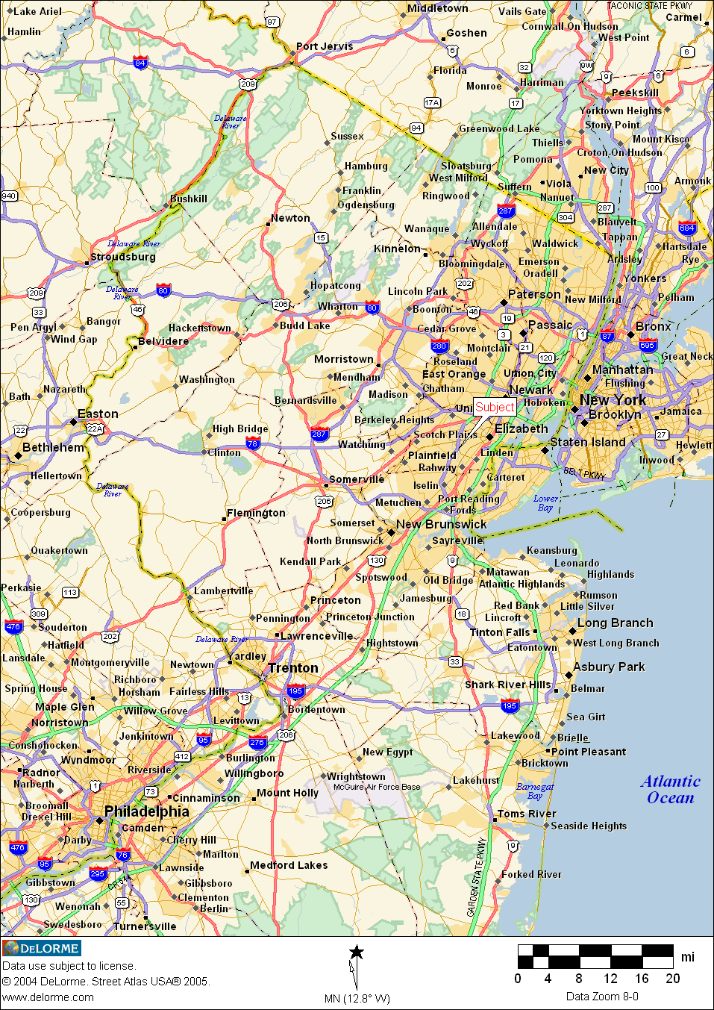

AERIAL MAP

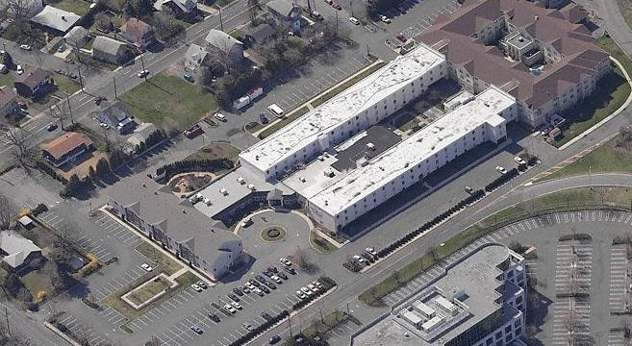
SUBJECT PHOTOGRAPHS
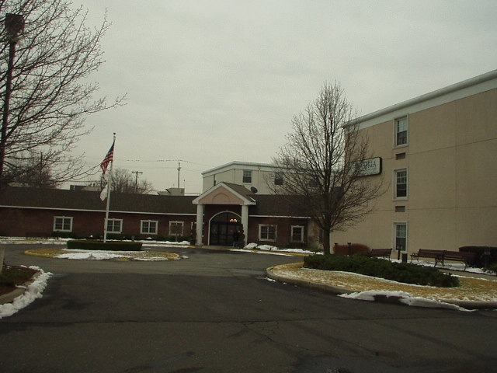

View of Front Lobby and Reception Entrance of Subject Property

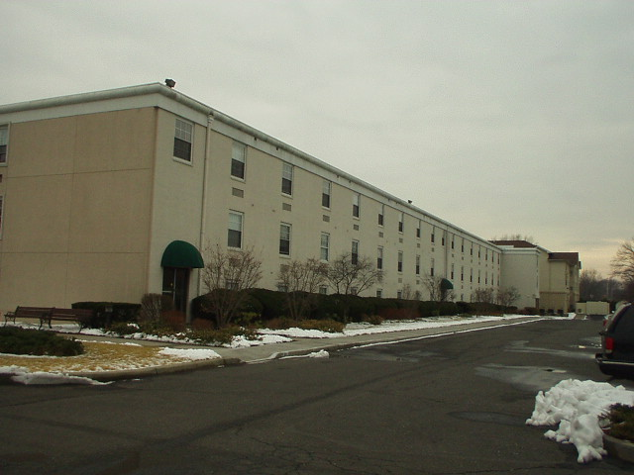

View of North Side Residential Wing of Subject Property
SUBJECT PHOTOGRAPHS

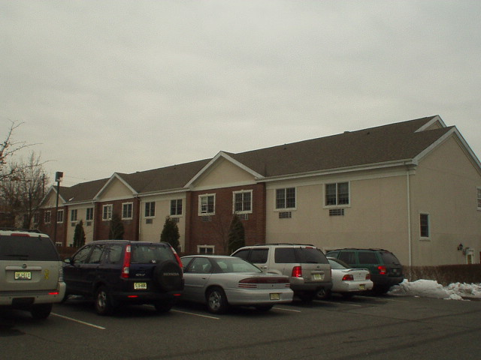

View of East Side New Residential Wing of Subject Property

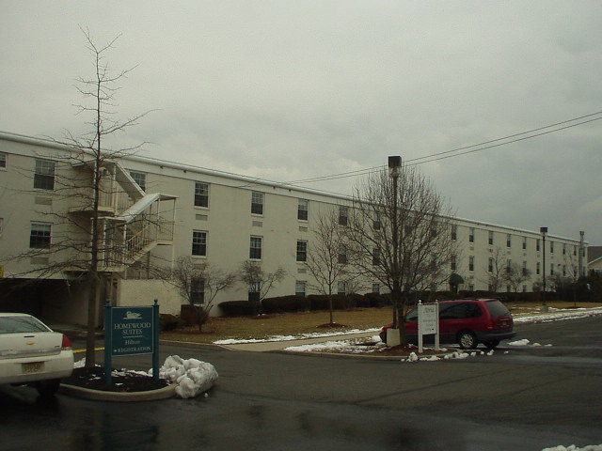

View of Rear of Subject Property and South Residential Wing
SUBJECT PHOTOGRAPHS

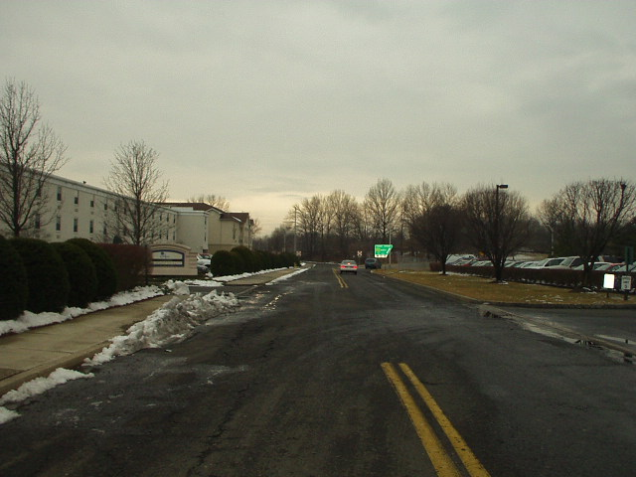

Street Scene – Jackson Drive looking West

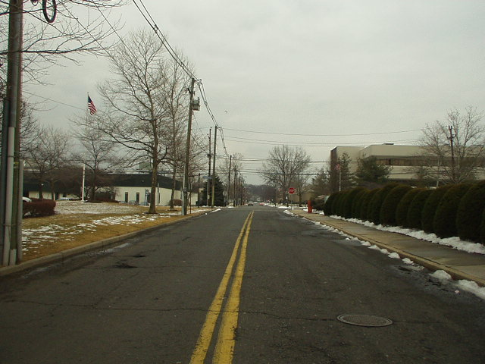

Street Scene – Jackson Drive looking East
SCOPE OF THE ASSIGNMENT

Appraisal Associates, Inc. has been engaged by the Township of Cranford to estimate the Market Value of the subject property as of October 1, 2004 and October 1, 2005. The property is located at 10 Jackson Drive and is a one, two and three story senior living facility known as “Atria Cranford”. The appraisal is being prepared to assist in an appeal of the assessments levied upon the property for the tax years 2005 and 2006.

A personal inspection has been made of the subject property and an analysis has been made of the market and economic conditions as they affect the subject. In this assignment the appraisers will consider all three approaches to value, The Cost Approach, The Income Approach, and The Market Data Approach. The value conclusions from these three approaches, if all are utilized, will then be reconciled into a Final Value Estimate.

MARKETING TIME

The appraiser estimates that if this property were exposed to the market for the purpose of obtaining a purchaser at this time and professionally marketed, it would require less than twelve months to consummate a sale. This time frame is based upon the subject’s location and the activity of these types of facilities to be purchased by regional and national organizations that own and operate them.

EXPOSURE TIME

It is the opinion of the appraisers that if the subject property was exposed to the marketplace in recent months prior to the effective date of this appraisal and professionally marketed, it would have sold within a time frame of less than twelve months. This judgment is based upon the positive factors affecting the subject identified above in our Marketing Time analysis and the absence of any negative influences in the marketplace within the recent past which would have diminished the subject’s value as an investment.
CONTINGENT AND LIMITING CONDITIONS

The appraiser(s) assumes no responsibility for those matters legal in character, nor render any opinion as to the title, which is assumed to be good. The legal description, if any furnished, is assumed to be correct. All existing liens and encumbrances have been disregarded and the property is appraised as though free and clear under responsible ownership and competent management.

A personal inspection of the property has been made. Areas and dimensions of the property were not physically measured but were furnished by the principal, or from plot plans furnished by the principal or from the appraisers’ files. Maps or sketches, if any included in this report, are to assist the reader in visualizing the property. We have made no survey of the property and assume no responsibility for the accuracy of any survey supplied to us and subsequently used.

In conjunction with the preceding paragraph, the appraiser(s) have not been apprized of or are qualified to ascertain the existence of Radon, a radioactive gas which occurs naturally in the soil of certain identified areas. This gas, in concentrated form, has been shown to be detrimental and its existence would create a negative impact on value. As in the above instance, the value estimate assumes the subject is free and clear of Radon Gas.

The Americans with Disabilities Act ("ADA”) became effective January 26, 1992. The appraisers have not made a specific compliance survey and analysis of this property to determine whether or not it is in conformity with the various detailed requirements of the ADA. It is possible that a compliance survey of the property, together with a detailed analysis of the requirements of the ADA, could reveal that the property is not in compliance with one or more of
the requirements of the act. If so this fact could have a negative effect upon the value of the property. Since the appraisers have no direct evidence relating to this issue, possible non compliance with the requirements of the ADA in estimating the value of the property has not been considered.
CONTINGENT AND LIMITING CONDITIONS (Continued)

An analysis of local conditions and all relevant data has been made to the extent deemed practical. The appraiser(s) certifies that to the best of his knowledge and belief, such factual matters are true and correct and that no important factors affecting the value of this property were knowingly overlooked or withheld. Market data has been taken from sources deemed to be reliable but which could not be verified in all cases. The resultant estimate of market value is predicated on the financial structure prevailing as of the date of value.

This appraisal report sets forth all of the limiting conditions (imposed by the terms of the assignment or by the undersigned) affecting the analysis, opinions and conclusions contained in this report.

Possession of this report, or a copy thereof, does not carry with it the right of publication, nor may all or any part of the contents of this report be conveyed to the public through advertising, public relations, news, sales or other media, without written consent and approval of the authors, particularly as to value conclusions and the identify of the appraisers or firm with which they are connected.

The distribution of the total valuation in this report between land and improvements applies only under the existing program of utilization. The separate valuations for land and buildings must not be used in conjunction with any other appraisal and are invalid if so used.

The appraiser(s) shall not be required to give testimony or appear in court by reason of this appraisal, unless specific arrangements for these services are otherwise arranged.

All of the facts, conclusions and observations contained herein are consistent with information available as of the date of valuation. The value of real estate is affected by many related and unrelated economic conditions, local and national. We, therefore, assume no liability for any unforeseen precipitous change in the economy.

APPRAISAL PROCESS

An appraisal is an estimate of value. In order to arrive at this estimate, the appraisers follow an orderly procedure by which the appraisal problem is defined; the work necessary to solve the problem is planned; and the data involved is acquired, classified, analyzed, interpreted and translated into an estimate of value. The entire process is referred to as the appraisal process.

In determining the value estimate of a parcel of real estate, the appraisers consider three separate but interrelated approaches to value. These are the Cost, Income and Market Data Approaches. In the Cost Approach, the appraisers estimate either the reproduction cost-new or the replacement cost-new of the improvements and then the accrued depreciation (physical deteriorations, functional and economic obsolescence) is deducted to arrive at a depreciated cost to which is added the value of the land.

In the Income Approach, the appraisers first determine the gross potential income for the property from which are deducted allowances for vacancy and credit losses, as well as operating expenses, in order to arrive at a net income. This net income is then converted into value through a process known as capitalization.

The Market Data Approach is primarily a comparative method, whereby the appraisers extract from the market similar properties that have sold. These properties or comparables are then adjusted to the subject and a final interpretation is then made in order to arrive at a value for the subject. Since the Market Data Approach is based upon the reaction of informed buyers and sellers, it is this methodology that is used to ascertain components in both the Cost and Income Approaches.

Only under optimum conditions when all factors affecting value are in balance will the value estimates arrived at by the three approaches be equal. More than likely each approach will produce different values all falling within an acceptable range of each other.
MARKET VALUE DEFINITION

“The most probable price which a property should bring in a competitive and open market under all conditions requisite to fair sale, with the buyer and seller each acting prudently and knowledgeably, and assuming the price is not affected by undue stimulus. Implicit in this definition is the consummation of a sale as of a specified date and the passing of title from seller to buyer under conditions whereby

- buyer and seller are typically motivated;
- both parties are well informed or well advised, and acting in what they consider their best interests;
- a reasonable time is allowed for exposure in the open market;
- payment is made in terms of cash in United States dollars or in terms of financial arrangements comparable thereto; and
- the price represents the normal consideration for the property sold unaffected by special or creative financing or sales concessions granted by anyone associated with the sale.”
PURPOSE OF THE APPRAISAL

The appraisal was made for the purpose of estimating the Market Value of the subject property, including land and buildings as of October 1, 2004 and October 1, 2005.

INTENDED USE/INTENDED USERS

The appraisal is intended to be used in conjunction with an appeal of the 2005 and 2006 tax year assessments of the property by the property owner. The intended users of the report are Mr. Peter Barnett, Tax Assessor of the Township of Cranford and Mr. Robert Renaud, Township Attorney and other directly related with the tax appeal process.

PROPERTY RIGHTS APPRAISED

The property rights are all rights existing in the fee simple estate as of the appraisal date. These rights are the legal and economic properties of the owner that may rightfully be exchanged for money or equivalent goods. Property rights inherent in the ownership of tangible personal property, and intangible benefits, are not the subject of this report.

OWNERSHIP

Cranford Development, LLC
501 South 4th Avenue – Suite 140
Louisville, Kentucky 40202

HISTORY OF THE PROPERTY

The property was purchased on September 17, 2003 in the amount of $17,574,500 as recorded in Deed Book 5391, Page 337 at the County of Union Clerk’s Office. The property was purchased from HealthCare Reit, Inc., located at 1 Seagate – Suite 1500, Toledo, Ohio. This sale is considered not arm’s length since the grantee (Cranford Development, LLC) was a shareholder of the grantor at the time of sale and this facility was part of a portfolio of facilities. The property was purchased by HealthCare Reit, Inc. from AVR Realty on December 16, 1996 in the amount of $22,000,000 as recorded in Deed Book 4468, page 167. Prior to this sale, AVR Realty converted Block 644 into three condominium units. The subject property has 66.66% undivided interest in the common elements as per the master deed.
ASSESSMENTS AND TAXES

The subject is identified as Block 644, Lot 1.01, Qualifier C02 by the Township of Cranford tax rolls and incurs the following taxes and assessments:

Year 2005 2006
Land $ 4,588,700 $ 4,588,700
Improvements $11,311,300 $11,311,300
Total $15,900,000 $15,900,000

Tax Rate/$100 of Assessed Value $3.923 $4.191
Real Estate Taxes $623,757 $666,369

Equalization Ratio 51.34% 46.28%
Effective Tax Rate/$100 of Value $2.0140 $1.9375
Equalized Value $30,970,004 $34,356,093

ZONING

The subject is located in the ROI – 1, Campus Research, Office and Industrial District of the Township of Cranford. This zone allows more than one principal building on a given site. The following are the principal permitted uses of this zone:

Business, administrative and executive and professional offices
Research and Laboratories
Industrial and Manufacturing Uses
Warehouses
Motels and Hotels
Essential services

Conditional uses are as follows:

Pilot Plant in conjunction with research laboratory
Professional offices in dwellings
Institutional and Public Uses

ZONING (Continued)

Size, bulk, and set back restrictions are as follows:

Minimum Lot Size: 100,000 square feet
Minimum Lot Width: 250 feet
Minimum Front Yard: 50 feet
Minimum Side Yard: 50 feet (one side) 100 feet (both sides)
Minimum Rear Yard: 100 feet
Maximum Floor Area Ratio: .50
Maximum Building Height: 3 stories or 45 feet
Maximum Impervious Surface: 70%
Minimum Office Parking: 1 for each rental unit and, in addition, compliance with the requirements for each additional use located on the property, such as retail, restaurants, eating and drinking places and meeting rooms.

The subject property as presently improved does not conform to the permitted or conditional uses and the bulk and setback restrictions allowed in the ROI-1 zone. The property received a variance from the Board of Adjustment, Township of Cranford for its nonconforming use and bulk and setback restrictions as recorded in Instrument No. 6-96 memorialized on May 20, 1996.

TAX MAP

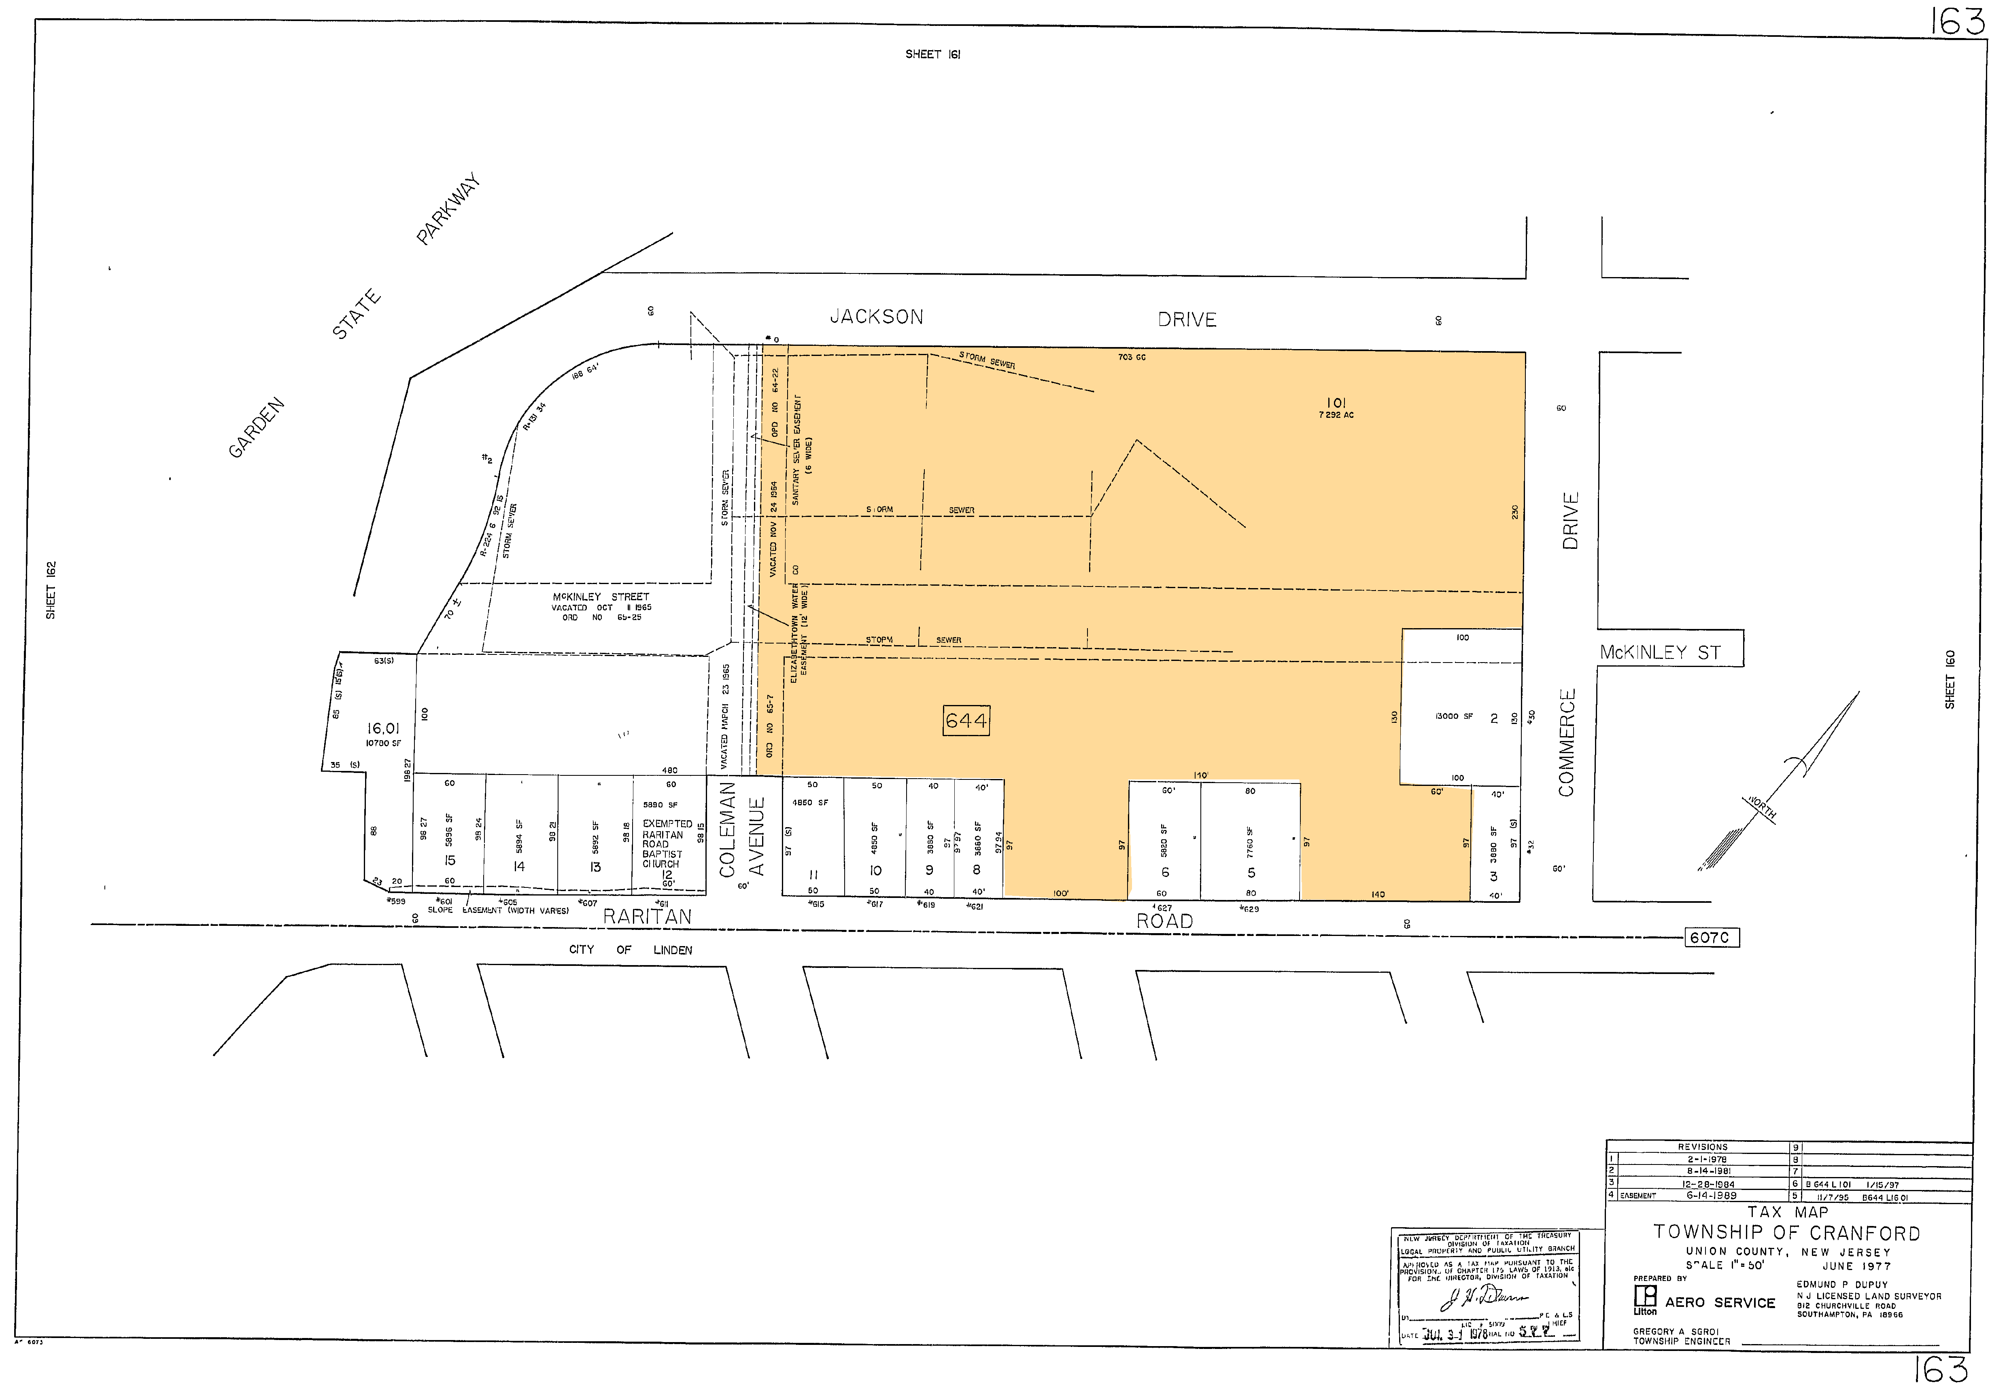

AREA DATA

The subject property is located in the Township of Cranford, Union County, New Jersey.

State of New Jersey
New Jersey, the Garden State, is one of the smallest states in the nation. The State of New Jersey is located in the center of the great metropolitan complex that forms the eastern seaboard, extending from Boston Massachusetts, to Norfolk Virginia, making New Jersey one of the most important commercial centers nationwide.

New Jersey contains an area of 7,414 square miles of land area and approximately 8,717,925 persons according to the 2005 Federal Census. This is an increase of 3.6 percent or 303,575 people over the 2000 Federal Census figure of 8,414,350. There is a density of 1,175 persons per square mile, which is one of the highest of any of the other 50 states. The state’s population resides in the 3,443,981 housing units that are located throughout the 21 counties.

In 2005, New Jersey’s median income was $61,700, compared to the national average of $46,200. New Jersey is ranked first in the nation, just ahead of Maryland, Connecticut, Hawaii and Massachusetts, according to the 2005 Census information, taken from The Star-Ledger. The data showed that 43 percent of New Jersey households earn at least $200,000. The Census also showed that New Jersey’s median home value rose by 94%, from $171,988 in 2000 to $333,900 in 2005. This figure is 99 percent above the national average, and ranks New Jersey fifth in the nation for median home values.

New Jersey has some of the nation’s busiest seaports and airports. The Port Authority of New York and New Jersey is the world’s most complete port and handles more cargo than any other port in the United States. The Delaware River Port stretches 135 miles along the New Jersey, Pennsylvania and Delaware coasts. Newark Liberty International Airport is one of the fastest growing airports in the world, servicing over 34 million passengers in the year 2005.

In addition to its commercial assets, New Jersey also boasts superb recreational attractions. Excellent beaches stretch for 127 miles, from Sandy Hook to Cape May, making New Jersey a popular summertime resort. Other recreational facilities include Sussex County’s ski resorts, Atlantic City’s casinos, professional sports arena at the Meadowlands, and the Great Adventure theme and water park. The Garden State’s theaters, and museums, plus its proximity to New York and Philadelphia, provide easy access to a full range of cultural activities.
AREA DATA (Continued)

Union County
Union County, located in the northeast portion of New Jersey, is the second smallest of 21 counties in the state. In size, it is 103.08 square miles. The county is bounded by Essex County to the north, Morris and Somerset Counties to the west, Middlesex County to the south and the Arthur Kill to the east. Due to its close proximity to New York City, Union County is considered to be within the New York Metropolitan Region.

According to the 2005 estimate by the U.S. Census Bureau, the county has a population of 523,649 reflecting a density of 5,080 persons per square mile. This is an increase of .2% from the 2000 population of 522,541 and a 5% increase from the 1990 estimate of 498,766 persons. Total housing units increased from 2000 to 2005 to 195,122 from 192,945 or 1%. This increase is due to the housing boom experienced across the county, state and nation over the past few years. In fact the median home value in 2005 is $371,100, an increase of 97% over the 2000 census estimate of $188,800. In addition median household income in 2005 was estimated at $62,591 which is an increase from the 2000 estimate of $55,339. Sale and Marketing Management magazine has ranked Union County, and three other New Jersey counties, among the 25 most affluent suburban counties in the nation based on the median household effective buying income.

The large number of Fortune 500 companies in or near Union County provides a diverse array of employment options. Employment rates in Union County have lagged behind state and sometimes national figures because of the relatively high percentage of manufacturing jobs, however the number of jobs in manufacturing and their percentage of total employment have been shrinking for the past few years while the number of service and finance related job opportunities have been growing for the last ten years. Manufacturing companies still play a dominant role in the county’s economy employing approximately 15% of the workforce and is second only to educational, health and social services (18%). Finance, insurance and real estate (FIRE) however has been steadily growing within the county and is approximately 10% of the workforce. The following table contains the major employers in the county based upon the number of employees located in Union County.

AREA DATA (Continued)
Union County (Continued)

Major Union County Non-Government Businesses
Listed from 2003 UCEDC Major Employers Listing
Name | Location | Type of Business | # of Employees
Schering Plough | Kenilworth & Union | Pharmaceuticals | 4,745
Merck & Co. | Rahway | Pharmaceuticals | 3,700
Federal Express | Elizabeth | Info. & Package Delivery | 3,356
Overlook Hospital | Summit | Hospital | 3,000
Trinitas Hospital | Elizabeth | Hospital | 3,000
Lucent Technologies | New Providence | Communications | 2,000
Wakefern Foods | Elizabeth | Food Distribution | 1,400
Muhlenberg Medical Center | Plainfield | Hospital | 1,300
Bank of America | Various Municipalities | Banking | 1,125

The county’s proximity to New York and other major employment centers in the metropolitan area is accented by the network of highways serving the district and the mass transportation facilities that are available. The New Jersey Turnpike, the Garden State Parkway and U.S. Routes 1&9 are the major north-south freeways located in Union County. Interstate Routes 78 and 80 along with U.S. Route 22 offer east-west access to New York and Pennsylvania. In addition, New Jersey State Highways 24, 27, 28 and 35 are main thoroughfares as well as centers of commerce.

Bus service operated under the supervision of the New Jersey Transit Corporation is available in all 21 municipalities in Union County with local and express buses going to Newark, New York City and other points. Passenger rail service is available in 14 communities via New Jersey Transit and freight service is provided by Conrail. Air passenger and freight is supplied by major airlines operating out of Newark Liberty International Airport.

The outlook for the general economy of the Union County area is presently favorable, based upon the lack of overbuilding of speculative real estate, along with the high absorption of excessive commercial inventory left over from the speculative building of the early 1990’s. The present growth of the county is a promising indication of the area’s future potential since it is based upon true demand for goods and services and not speculative forecasting.
AREA MAP

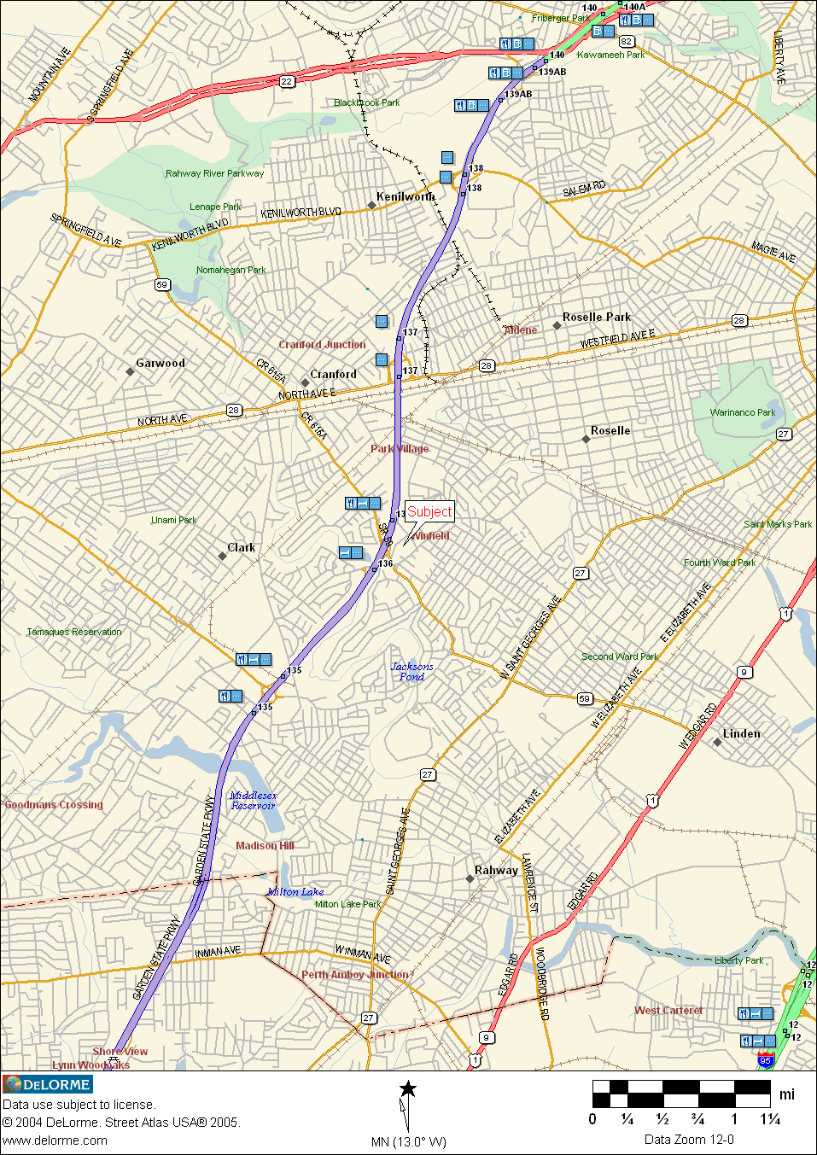
SENIOR HOUSING MARKET OVERVIEW

The market demand for the senior housing, primarily assisted living facilities, is being driven by the aging population, increased life expectancies and a decrease in the number of senior care facilities, specifically skilled nursing homes. The U.S. Census Bureau, in 2005, estimates there were 35 million Americans aged 65 and older, which is approximately 13% of the total United States population. The U.S. Census Bureau projects that in 2010 there will be 40 million Americans 65 and older and by 2020 there will be 54 million Americans.
 | 2000 | 2010 | 2020 | 2030 | 2040 | 2050
Total Population | 282,125 | 308,936 | 335,805 | 363,584 | 391,946 | 419,854
65 and older | 36,061 | 40,243 | 54,632 | 71,453 | 80,049 | 86,705
% of Total | 12.78% | 13.03% | 16.27% | 19.65% | 20.42% | 20.65%
(Numbers in thousands)
U.S. Census Bureau, 2004, “U.S. Interim Projections by Age, Sex, Race and Hispanic Origin”

In 1999, there were approximately 18,000 nursing homes with approximately 1.9 million total beds in the United States. In 2005, the number of nursing homes decreased to 16,032 with approximately 1.6 million total beds, based upon figures from the Department of Health and Human Services. The direct result of the decrease in demand for nursing homes is due to the increase in demand for non-nursing home senior care facilities, such as assisted living facilities.

Based upon statistics from the National Investment Center for the Senior Housing and Care Industries (NIC), in 2004 there were approximately 36,000 licensed assisted living facilities with over 900,000 residents within the United States an increase from 778,000 residents in 1999 and 362,000 residents in 1990, NIC estimates were based on state licensed facilities only and they estimate that in 2004 an additional 821,000 residents were in senior-oriented non-licensed “independent living units”. The popularity of assisted living and senior independent living facilities is causing pressure on skilled nursing facilities to close, or change their services offered.

Assisted living facilities provide care for seniors who need some level of help with activities of daily living (ADL), but wish to remain as independent as possible. Assisted living facilities were first created in the early 1980’s to bridge the gap between independent living and nursing homes, where the senior needed some assistance with daily activities, but did not need the level of a nursing home care or the expense. Since that time, the amount of assisted living facilities, care levels provided and activities offered have made these facilities a more attractive alternative to nursing homes.
SENIOR HOUSING MARKET OVERVIEW (Continued)

The late 1990’s experienced rapid growth and supply of assisted living facilities leading to a down turn in the Senior Housing Market. Many operators filed bankruptcy and many sold their facilities to larger regional and national operators who had the ability to charge lesser fees due to their economies of scale. In the early 2000’s this consolidation continued and through the consolidation it caused the assisted living facility market to thrive. By 2004 the top 10 companies had a capacity of 104,054 beds which represented 61% of the capacity of the top 50 providers. In 2004 the top 10 providers were as follows:

No. | Provider | Capacity
1. | Sunrise Senior Living | 29,745
2. | Alterra Healthcare Corp. | 14,930
3. | Atria Senior Living Group | 14,517
4. | Emeritus Assisted Living | 14,423
5. | Merrill Gardens | 7,877
6. | Assisted Living Concepts | 6,838
7. | Leisure Care | 4,516
8. | Hearthstone Assisted Living | 4,000
9. | Lifetrust America, Inc. | 3,915
10. | Southern Assisted Living, Inc. | 3,293
ALFA, Largest Providers Survey, June 18, 2004

The following table illustrates the fees charged by Nursing Homes and Assisted Living Facilities throughout the United States and Northern New Jersey:

 | NURSING FACILITIES |  | ASSISTED LIVING FACILITIES
 | National Monthly Base Rate | New Jersey Monthly Base Rate | National Monthly Base Rate | New Jersey Monthly Base Rate
2004 | $5,349 | $6,531 | $2,424 | $3,621
2005 | $5,785 | $6,980 | $2,522 | $3,920
2006 | $5,909 | $8,241 | $2,691 | $4,203
Compiled from Genworth’s 2004, 2005 & 2006 Cost of Care Survey

SENIOR HOUSING MARKET OVERVIEW (Continued)

As shown in the chart above, assisted living facilities’ fees are lower than nursing home fees both nationally and in Northern New Jersey. This is the main reason why assisted living facilities have become very popular in the past two decades. While the late 1990’s showed troubling signs with overexpansion of the market, from 2000 to present the senior housing market has rebounded and in some areas of the country demand has outpaced supply. The following chart shows that occupancy has been on the rise since 2001.

Occupancy Rates by Facility Type
Type of Facility | 2006 | 2005 | 2004 | 2003 | 2002 | 2001
Independent Living | 93% | 92% | 90% | 91% | 89% | 88%
Assisted Living | 89% | 89% | 88% | 85% | 86% | 84%
Nursing Homes | 88.5% | 86% | 85% | 88% | 85% | 84%
CCRC | 91% | 91% | 92.5% | 90% | N/A | N/A
Compiled from NIC Key Financial Indicators as published on www.nic.org

The occupancy rates reported above vary from a low of 84% in 2001 when the assisted living facility market was over saturated with new supply to a high of 89% in 2005 and 2006 when the assisted living facility market had stabilized. The Independent Living category is essentially an apartment building for senior citizens. These types of facilities, do not help with the seniors assisted daily living, however they provide meals, transportation and other services at additional costs. Assisted Living Facilities provide all the attributes of Independent Living facilities along with Assistance in Daily living (ADL)’s. Nursing Homes provide skilled nursing and doctor attention to residents, along with substantial care beyond the offering of Assisted Living facilities.

Most senior housing facilities fall into the category of Continuing Care Retirement Communities (CCRC). These facilities feature a combination of independent living units, assisted living units and skilled nursing units. CCRC’s are currently very popular, since it offers at minimum two types of care levels and does not require the residents to move to another facility.

SENIOR HOUSING MARKET OVERVIEW (Continued)

Another indicator that the market for senior housing, mainly assisted living facilities, has rebounded is loan volume and performance. Based upon information located on the NIC Website, the following table was compiled:

 | 2006 | 2005 | 2004 | 2003
Loan Volume | $1.64 Billion | $1.2 Billion | $783 Million | $568 Million
Loan Performance | 99.4% | 98.75% | 96% | 93.5%
Loan Volume and Performance is based on 3rd Quarter information for each year

Finally, Capitalization Rates for these types of property classes have been an additional sign that the market has gotten stronger. The table below shows capitalization rates as reported:

Type of Facility | 2006 | 2005 | 2004 | 2003
Independent Living | 7.7% | 8.2% | 9.1% | 10.3%
Assisted Living | 8.7% | 8.9% | 8.9% | 11%
Skilled Nursing | 12.7% | 12.9% | N/A | N/A
CCRC’s | N/A | 8.6% | 9.0% | N/A
Capitalization Rates are based on 3rd Quarter for each year.

The senior housing market within the United States presently is considered a strong rebounding market. The downturn of the late 1990’s is no longer a factor within this market based upon the performance of these facilities from 2001 to the present. While nursing facilities lag behind the rest of the senior housing facility types, the senior housing market in general is considered a strong and viable market for the foreseeable future.

NEW JERSEY SENIOR HOUSING MARKET

In 2003 the U.S. Census Bureau estimated the population in New Jersey of residents 60 years and older at 1,495,460 persons, which totals 17.3% of the New Jersey Population. This is an increase of 3.6% from the 2000 Census of 1,443,782 persons 60 years and older and an increase of 7.2% over the 1990 Census of 1,394,958 persons. The largest population growth occurred in people ages 85 and older at 42.3%, with the people ages 80-84 the second largest at 30%. The population of people over the age of 60 years is expected to grow substantially to 2,500,000 by 2030. This is directly due to the aging baby-boom generation, people born between 1946 and 1964.

The population density of people 60 years and older in New Jersey in 2003 was 202 persons per square mile of land area. Hudson County had the highest population density for residents with 1,972 persons 60 and older per square mile, with Union County ranking 3rd on the list with 890 persons 60 and older per square mile. Union County ranks 7th in the state out of the 21 counties with 91,871 persons over the age of 60 in 2003. The chart on the following page summarizes the estimated population by age groups and counties.

As of December 21, 2004 there were 190 Assisted Living Facilities (ALF) and Comprehensive Personal Care Homes (CPCH) in the state of New Jersey with approximately 11,777± residents. The Department of Health and Senior Services within the State of New Jersey is the governing body for licensing of the senior housing facilities. In the State of New Jersey there are two types of license a facility can obtain, an Assisted Living Residences License and a Comprehensive Personal Care Home License. These licenses were adopted in N.J.A.C. 8:36 created on November 15, 1999 and recently updated on September 22, 2006. Assisted Living Residences and Comprehensive Personal Care Homes are intended to promote “aging in place” in a homelike setting for “individuals capable of responding to their environment, making their wishes known, interacting with others and engaging in independent activity.” The significant difference between the two licenses and facilities is that a resident of an assisted living facility has less needs and are more independent where as a Comprehensive Personal Care Home is for residents who require more assistance with daily living, but who are still, for the most part, independent.
NEW JERSEY SENIOR HOUSING MARKET
Estimated 2003 Population 60 Years and Older by Age Group and County in New Jersey
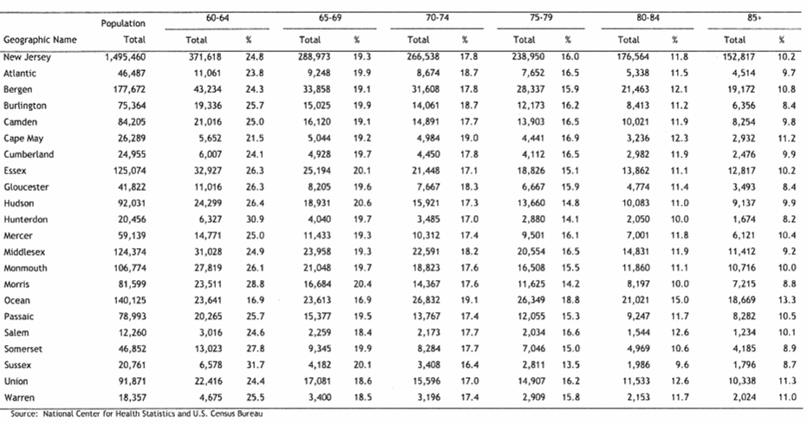

NEW JERSEY SENIOR HOUSING MARKET

In 2005, the Department of Health and Senior Services surveyed all 190 Assisted Living Facilities and Comprehensive Personal Care Homes licensed in the state. The following are the results of the survey:

Residents Age Distribution
Younger than 70 | 5%
70-74 | 4%
75-79 | 11%
80-84 | 24%
85-89 | 28%
90-94 | 20%
95 + | 8%
Median Age | 85.1
Additional Statistics
Females | 77%
Males | 23%
Mean Length of Stay (LOS) | 24 months
Medicaid Residents | 2,101
Residence Requiring No Assistance with ADL | 30%
Residence Requiring Assistance with Medication | 64%

The study also noted that the number of licensed facilities grew by 16% from January 1, 2002 to December 31, 2004; however this rate of growth was considerably less than the rate of growth during the peak years of 1997 to 2000.

The senior housing market in the State of New Jersey is similar to the rest of the country in that it is rebounding strongly after the collapse of the market in the late 1990’s. As the table on the preceding pages indicates, the amount of New Jersey residents in 2003 ages 80-89 (the two highest age groups in senior housing) were 329,381. This aging population, similar to the country, is creating a demand for senior housing facilities. As of 2004 there were 190 facilities in New Jersey capable of accommodating 11,777± residents, which indicates there is a current demand and the need for more senior housing facilities within the coming years.
LOCAL SENIOR HOUSING MARKET

In defining a market for assisted living facilities, the main consideration is maximum driving time. A maximum drive time of a distance no more than 20 minutes is generally considered acceptable to family members and friends of residents of assisted living facilities. Facilities beyond a twenty minute drive time are typically not chosen by family members except on a special purpose or needs basis.

With this in mind, we have analyzed the general demographics within a 5, 10 and 20 minute drive time of the subject property. The following tables contain demographic profiles and projections of residents 55 years of age and older within the above drive times.

Age 55+ Profile within 5 minute drive time
 | Census 2000 | 2006 | 2011 | 2006-2011  Annual Rate
Total Population | 90,703 | 92,134 | 93,265 | .24%
Population 55+ | 23,408 | 24,086 | 26,096 | 1.62%
Median Age | 38.8 | 40.1 | 41.6 | .74%
Households | 34,515 | 34,481 | 34,701 | .13%
% Householders 55+ | 40.7% | 41.1% | 43.5% | 1.14%
* Report compiled by data from Esri and STDBOnline

Age 55+ Profile within 10 minute drive time
 | Census 2000 | 2006 | 2011 | 2006-2011  Annual Rate
Total Population | 539,531 | 554,689 | 565,130 | 0.37%
Population 55+ | 118,990 | 127,048 | 138,116 | 1.68%
Median Age | 36.4 | 37.3 | 38.4 | 0.58%
Households | 193,957 | 196,555 | 199,350 | 0.28%
% Householders 55+ | 36.6% | 37.9% | 40.2% | 1.19%
* Report compiled by data from Esri and STDBOnline

LOCAL SENIOR HOUSING MARKET

Age 55+ Profile within 20 minute drive time
 | Census 2000 | 2006 | 2011 | 2006-2011  Annual Rate
Total Population | 2,597,842 | 2,684,923 | 2,752,118 | 0.5%
Population 55+ | 543,888 | 584,697 | 643,644 | 1.94%
Median Age | 35.4 | 36.2 | 37.1 | 0.49%
Households | 937,795 | 961,105 | 983,424 | 0.46%
% Householders 55+ | 34.9% | 36.2% | 38.6% | 1.29%
* Report compiled by data from Esri and STDBOnline

The competing facilities within a 20 minute radius from the subject property have been researched and surveyed. The following is the results of our survey.
 | Facility Name/Location | Distance from S.P. | No. of Units | Type of Units | Rent/  Month | Occu-pancy | Remarks
1 | Sunrise of Westfield  240 Springfield Ave.  Westfield, NJ 07090 | 3.71 miles  10 minutes | 93 | 1 BR (Sm.)  1 BR (Lg.) | $4,000  $7,000 | 97% | Licensed as an assisted living facility. Offers Independent living, Assisted living and Alzheimer’s care. New Resident fee additional. Rents based on room rate, a  nd care levels.  Verified by: Robyn Bailey
2 | Carteret Senior Living  1155 East Jersey Street  Elizabeth, NJ 07201 | 6.22 miles  15 minutes | 99 | Studio  One BR | $2,872  $3,061 | 90% -  95% | Licensed as a comprehensive personal care home facility. The facility is a converted hotel, built in 1927. Offers Independent living, Assisted living and Alzheimer’s care. Rents based on room rate and care levels.  Verified by: Suzzette Fox
3 | The Chelsea of Fanwood  295 South Avenue  Fanwood, NJ 07023 | 6.23 miles  15 minutes | 95 | Studio | $4,000 | 100% | Licensed as an assisted living facility. The facility is a converted hotel. Offers Independent living, Assisted living and Alzheimer’s care. New Resident fee additional. Rents based on room rate, and care levels.  Verified by: Jennifer Ricci
4 | Brighton Gardens of Mountainside  1350 Route 22 West  Mountainside, NJ 07092 | 6.78 miles  16 minutes | 141 | Studio  One BR | $3,000  $3,750 | 92% | Licensed as an assisted living facility. Offers Independent living, Assisted living and Alzheimer’s care. New Resident fee additional. Rents based on room rate, and care levels.  Verified by: Lisa Williams
5 | Spring Meadows of Summit  41 Springfield Avenue  Summit, NJ 07901 | 13.53 miles  18 minutes | 98 | Studio  One BR | $4,450  $5,500 | 95% | Licensed as an assisted living facility. Offers Assisted Living only. New Resident fee additional. Rents based on room rate, and care levels (with two ADL’s included).  Verified by: Susan Katz
* Notes: Mileage and drive times were determined by Map Quest
Rental rates supplied were averages of 2005 and 2006.

LOCAL SENIOR HOUSING MARKET

The survey on the previous page shows the five (5) licensed competitive properties within a 20 minute radius of the subject property that offer similar services and amenities. The occupancy rates were for the full year of 2006, although the persons interviewed noted that their occupancy rates have not changed from year to year dramatically.

From the tables on the preceding pages it can be determined that on average, more than 25% of the area within a 20 minute drive from the subject property is older than 55 years of age, indicating that there is a need for senior housing facilities within a 20 mile radius from subject. In addition from our survey of the five (5) competing facilities we determined that there are 526 senior housing units, excluding the subject property, within the 20 mile radius as well. The results of our survey and the demographics within this region determine that there is a need for senior housing facilities.

5, 10 AND 20 MINUTE DRIVE MAP

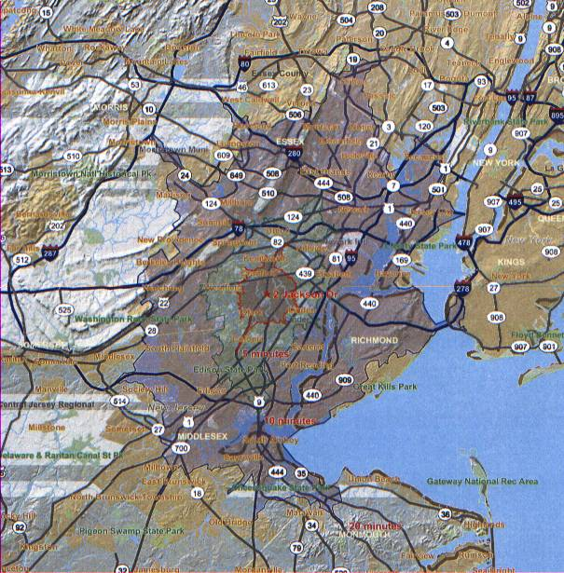

NEIGHBORHOOD DATA

The Township of Cranford encompasses 4.9 square miles of land located in the central portion of Union County, approximately 20 miles west of New York City. The Township is basically residential and as of the 2005 Census Data there are 22,728± residents. The majority of the residents occupy single family detached homes. The land area in the township, except for certain isolated parcels, is completely developed.

Cranford is one of Union county’s older established residential communities, benefiting from the Cranford Train Station, located along New Jersey Transit’s Central New Jersey rail corridor along the Raritan Valley line. This provides good commuter access to employment centers in Newark and New York City. Cranford is also readily accessible to the region’s main highways, with two interchanges of the Garden State Parkway located within the Township. State Route 28, also known as North Avenue and South Avenue, bisects the Township and is the focus of much of its commercial activity.

Cranford is the location of the main campus of Union County College. The Rahway River, which runs north-south through the center of town, is bordered for most of its length by park areas creating a greenbelt which widens in the northern end of the Township into Nomahegan Park. In addition to parks, Cranford benefits from a full range of public facilities and services typical for a community of its size, including a library, schools, police and fire protection.

Cranford has a Township Committee form of government, full-time police and fire protection, a K through 12th grade public school system, library and other facilities and/or amenities of a typical New Jersey community. The Township is considered stable and desirable and sought after by home buyers. The foreseeable future should be that of a fully mature, stable community providing an environment suitable for both the residential and commercial inhabitants.

The subject property is located on the south side of the Township of Cranford within the Cranford Business Park. The Cranford Business Park contains 22 buildings and over 1.5 million square feet of rental space. The subject is conveniently located at the entrance and exit of Exit 136 of the Garden State Parkway. Located within the neighborhood are offices, retail, light industrial and residential uses.
SUBJECT PROPERTY LOCATION MAP

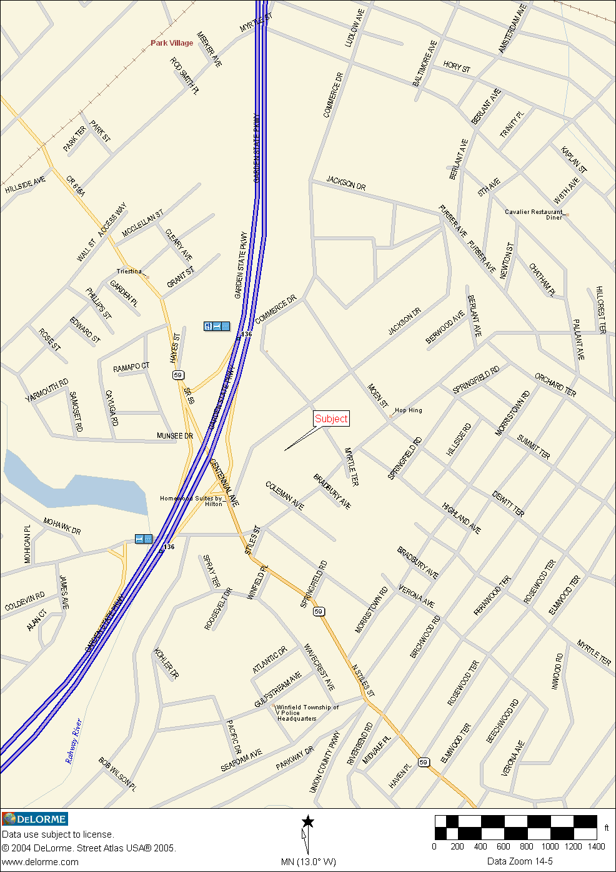
SITE DATA

The subject site is located on the north east corner of Centennial Avenue at its intersection with Raritan Road. Although not precisely having corner ownership, it can be said to be located at said intersection. The site is almost rectangular in shape and is bounded by Jackson Drive, to the north, Commerce Drive to the east and rears of properties facing Raritan Road to the south. It has access from each of the aforementioned streets. Access from Raritan Road is through Coleman Avenue, which serves the subject site only.

The site is readily accessible to the Garden State Parkway, whose north bound entrance ramp is at the entrance to the subject property. The south bound entrance is on the other side of the Parkway, over the Centennial Avenue Overpass, and readily accessible.

The site consists of 2.447± acres or 106,591± square feet. The parcel is mostly level and is encumbered with right of way cross easements with the neighboring condominium units. All public and private utilities are available to the site.

FLOOD DATA

The subject site is located in a Zone C flood zone according to the FEMA Flood Map Community Panel Number 345291 0002B, effective February 16, 1983. The C Flood Hazard Zone is an area of minimal flooding.
DESCRIPTION OF IMPROVEMENTS

The subject is improved with a one, two and three story 219 unit senior living facility containing approximately 121,428± square feet. The building was originally built in 1967 and in 1993 was completely renovated. In 1997 a portion of the building was demolished and an addition of 50 units was built. The facility is licensed for both Comprehensive Personal Care Home for 176 residents and Rooming and Boarding House for 146 residents. In total the facility has a maximum resident capacity by license of 322 residents.

The facility contains three (3) wings. Two of the wings, where the majority of the resident units are located, are identically constructed. The third wing is a two (2) story new section of the building built in 1997 housing the remaining resident units. The three wings are connected by a one story structure that contains administrative offices, dining room, large activity room, health room, beauty salon, poolroom, library, gift shop, kitchen and other similar type activity/support areas.

The resident rooms are outfitted with bed, dressers, night tables, television and other items of furniture that can be a combination of ownership (either belonging to the resident or to “Atria”). Each unit has a private bath and emergency phones for immediate help, along with individual heating and air conditioning units.

The rooms, hallways and other areas are decorated with wall coverings, carpeted floors and decorative lighting. The main entrance/lobby area contains a reception area that also acts as a monitoring station for emergency calls within the facility. The activity area houses a large fireplace with doors leading to an outside garden/patio area and a coffee/drink station.

The on-site improvements consist of macadam parking, striping, lighting, Belgium block curbing and concrete walkways. The property is landscaped along its perimeter, around the building and front lawn which has matured shrubbery and trees.

DESCRIPTION OF IMPROVEMENTS

The following is a further description of the property.

Use - Senior Housing Facility
Age - 1967 with a full renovation of in 1993 and an addition in 1997
Size - 121,428± square feet
Foundation - Poured concrete footings
Exterior Walls - Brick on masonry block
Windows - Double thermal pane
Roof Structure - Concrete deck planking on older section, gable style asphalt shingle on new section
Frame - Masonry bearing walls
Floor Structure - Concrete on grade and concrete deck planking on upper floors
Floor Covering - Carpeting over concrete in most areas, with vinyl tile and ceramic tile flooring in selected areas.
Ceiling - Textured finish to the underside of concrete deck with areas containing suspended acoustical 2’ x 4’ ceiling tiles.
HVAC - Thu-wall heat and air conditioning units
Electrical - Recessed fluorescent and accent lighting. Circuit break panel, ample electrical service, emergency back-up generators
Plumbing - Copper and cast iron piping, adequate lavatories
Elevators - “Dover” 2,500 lb. Capacity, 3 stop, “Nation”, 2,500 lb capacity 3 stop and “Dover” 2,500 lb. Capacity, 2 stop
Kitchen - Full commercial kitchen with stainless steel figures, walk-in freezers and refrigerators and large cooking and warming ovens.

The improvements are considered to be in good condition and reflect on going maintenance and upkeep.
UNIT LAYOUT

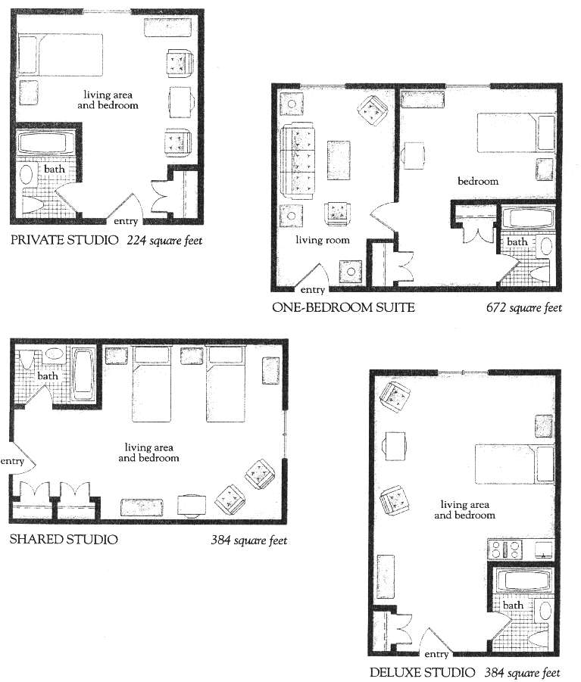
HIGHEST AND BEST USE

Highest and best use, as it relates to the land and improvements, is defined as follows:

“The reasonable probable and legal use of vacant land or an improve property, which is physically possible, appropriately supported, financially feasible, and that results in the highest value.”

The concept of highest and best use represents the premise upon which value is based and the most fundamental and significant stage in the valuation process, as it is the basis of all subsequent procedures. The study of highest and best use takes into consideration the analysis of the land or site as though vacant and the analysis of the property as improved.

The analytical process entails four criteria which are considered sequentially. The criteria are as follows:

Physically Possible – those uses which are possible from a purely physical standpoint. Property uses that are within the realm of possibility, but are not speculative in nature or otherwise improbable, are considered.

Legally Permissible – those legally permitted uses not limited by such factors as zoning, environmental or deed restrictions.

Financially Feasible – a determination of which among those physically possible and legally permitted utilization is expected to produce a positive return.

Maximally Productive – a determination of which among those financially feasible uses will produce the highest rate of return of value is the highest and best use.
HIGHEST AND BEST USE (Continued)
As Vacant

The subject property is situated in an ROI – 1, Campus Research, Office and Industrial District, which permits a variety of uses.

Physically Possible
The subject parcel is of sufficient size to be developed with a variety of different and permitted uses.

Legally Permitted
The current zoning regulations under the ROI - 1 Zone, Campus Research, Office and Industrial zone permits: office, industrial, warehouse, hotel and research development.

Financially Feasible
Each of the permitted uses for the site is considered to be Financially Feasible. They are considered to produce the highest rate of return and are also homogenous with uses in the surrounding areas.

Maximally Productive
The maximally productive use of the site, as if vacant, would be to develop the site with a permitted use to the maximum density permitted by zoning, which would produce the highest net return.

As vacant, the highest and best use of the subject property would be for development with a use permitted by the zone.

As Improved

It is our opinion that the Highest and Best Use is represented by its present developed use. This use was granted by the board of adjustment and is homogenous with its neighborhood surroundings. In addition, there is a need for this type of facility within the area.
INCOME APPROACH

In utilizing the Income Approach to value, the appraisers are concerned with the present worth of the future potential benefits of a property. This is generally measured by net income which a fully informed person is warranted in assuming the property will produce during a foreseeable period. The typical buyer of income property invests in the anticipation of future benefits which includes cash flows, income tax advantages and capital gains at time of sale. The quantity, quality and durability of the net income is analyzed and then processed into an estimate of value. Therefore, the Income Approach requires the assembling and processing of various income and expense data, to wit:

- Estimating a rent schedule and percentage of occupancy for the subject property. This generally provides gross rental data and trends in rental and occupancy.

- Obtaining rent schedules, occupancy and expense analyses of comparable properties.

- Estimating expense data and operating costs for the subject property, if possible.

- Selecting the appropriate capitalization rate and/or the applicable technique for processing the net income.

The subject property has two licenses, a Comprehensive Personal Care Home (CPCH) license for 176 residents and a Rooming and Boarding House license for 146 residents, for a maximum capacity of 322 residents. The facility contains 219 available units or rooms and offers private rooms and shared rooms to their residents.

The following page contains the Income and Occupancy for 2002 through 2006 as reported by the property owner. The income is reported by the three types of residency offered; Independent, Assisted Living and Life Guidance residents. The chart also contains the average rental rates per occupied units.

INCOME APPROACH (Continued)

Income and Occupancy of Subject Property as Provided

INCOME APPROACH (Continued)

Income Analysis
The subject’s income is inconsistent from year to year, with 2003 the highest revenue at $8,446,197 and 2005 the lowest at $7,448,369. This inconsistency can be attributed to the low occupancy rates and total residents in 2004, 2005 and 2006 compared with 2003. In a meeting with Regional Vice President of Atria Senior Living Group, Randy Smith, it was noted that in spring of 2004, the facility was not compliant with the State of New Jersey’s Department of Community Affairs and the Department of Health. The “zealous” manager at that time, retained residents that needed more care than the facility was licensed to provide. The state assessed the facility and discharged 50 residents. In addition, per the state’s regulations, the facility was not allowed to accept new residents until these issues were cleared. According to Gene Caldwell with the State of New Jersey Department of Health and Senior Services, the property has received numerous citations for licensure violations. Ms. Caldwell provided us with the “licensing survey” for the property showing these violations.

The competing facilities from Page 19 of the report within the Local Senior Housing Market section offer comparable rentals for the subject property. These comparable rentals show a range from a low of $2,872 per unit per month to a high of $7,000 per unit per month. These rental rates, are averages of the different unit types and do not include additional assessment for level of care and new resident fees. The new resident fees at the competing facilities range from $500 to $5,000, with one facility not charging a new resident fee. The subject property’s “New Resident Service Fee” or as noted on the income statements “Net Processing Fee” is quoted in the brochure as equaling 30 days’ rent. The average rental rates per occupied unit for the subject property on the previous page includes all income sources, including care level assessments, new resident fee and other revenue.

The subject property’s advertised unit rental rates, as of October 1, 2005, per their brochure were as follows:

Semiprivate - $2,800
Studio - $2,900
Studio Deluxe - $3,350
One Bedroom - $3,750
Two Bedroom - $4,300
INCOME APPROACH (Continued)
Income Analysis (Continued)

The rentals rates do not include the additional monthly assessment or level of care fee. These fees were as follows:

Old Names New Names Fee
Living Plus Care Level 1 Plus $500 per month
Supportive Living Care Level 2 $500 per month
Supportive Living Plus Care Level 2 Plus $1,000 per month
Enhanced Living Care Level 3 $1,500 per month
Enhanced Living Plus Care Level 3 Plus $2,000 per month
Life Guidance Care Level 4 $5,500 per month
Life Guidance Plus Care Level 4 Plus $6,000 per month

The name of the assessment levels or care levels were changed in the beginning of 2004; however the brochure provided at the time of inspection utilizes the old names. The income statements provided for 2002 and 2003 reflect the old names and the income statements for 2004, 2005 and 2006 reflect their new names. Randy Smith, Regional Vice President, confirmed the name change and correlation between the old names and new names.

The income for the valuation years, 2004 and 2005 on a per unit rate, reflecting $2,458 and $3,333 for an independent unit, $2,979 and $3,065 for an assisted living unit and $4,130 and $3,743 for a life guidance unit. These actual rates achieved at the property are substantially lower than their advertised rates. On the whole, the subject property in 2004 and 2005 achieved $3,763 and $3,741 per occupied unit.

Occupancy
Occupancy levels for the subject property are significantly below the market occupancy rates. The five competing facilities had occupancy rates between 92% and 100% with one facility noting there has been a waiting list in the past few years. In addition, as noted on Page 13, of this report, occupancy rates since 2001 across all senior housing facility types nationwide have been increasing with independent living facilities at 90% in 2004 and 92% in 2005, assisted living facilities at 88% in 2004 and 89% in 2005 and comprehensive care retirement communities at 92.5% in 2004 and 91% in 2005. Finally, on Page 37, the expense comparables utilized in this report showed occupancy rates between 80% and 95%.
INCOME APPROACH (Continued)

The subject property in 2003 had an occupancy level of 87.5%, which is consistent with nationwide statistics. In 2004 and 2005 however, the occupancy levels dropped dramatically to 78.1% and 76.8%, respectively. The appraisers attribute the drop in occupancy rates due to the management of the facility in 2004 and the need for the State’s involvement. In addition, Randy Smith, Regional Vice President of Atria Senior Living, explained to us that the facility has undergone “substantial management changes in the past two years”, as a result of the mismanagement during 2004 and 2005.

In order to value the property, we have reviewed the occupancy levels from the competing facilities along with national and regional statistics. The appraisers conclude that the subject property was capable of obtaining an occupancy level of 85% during the valuation years, 2004 and 2005 if properly managed. Therefore our income analysis will utilize an 85% occupancy rate or 186 units occupied.

Income Conclusion
It is impossible to accurately predict the scenarios of unit types with the care level assessments available for each resident. In order to determine income for the facility, we have utilized the income generated on a per occupied unit basis, which was consistent in 2003, 2004 and 2005 at approximately $3,750 per month to stabilize the income for the property over the valuation years. This per month rate will multiplied by 186 units (as previously determined) and annualized produces $8,370,000 of Gross Income that will be utilized for the 2004 and 2005 valuation years.

EXPENSES

The following page contains a table of the expenses for the subject property from 2002 through 2006 as provided by the property owner. The method of reporting each detailed category was changed in 2004. In the table to follow, some categories in 2002 and 2003 were not individually itemized as they were in 2004, 2005 and 2006. These categories in 2002 and 2003 were lumped into the “other expenses” category. Therefore, 2002 and 2003 “other expenses” are significantly higher than in the 2004, 2005 and 2006 years, however, the categories of “Postage and Courier Expense”, “Computer Expense”, “Vehicle Expense”, “Bad Debt Expense”, and “Sales Tax and Licenses” each have zero values to offset this difference in their years.

INCOME APPROACH (Continued)

Expenses of Subject Property as Provided
* 2006 Expenses are for first 10 months as provided. The total 2006 expenses as provided in a non detail view showed $6,113,957
** 2002 and 2003 expenses provided were categorized in a different format than 2006, 2005 and 2004.

INCOME APPROACH (Continued)

The following table summarizes the occupancy, revenue and expenses of the subject property from 2002 through 2006. In addition we have also calculated the expense ratio for each year along with the operating margin (inverse of expense ratio).

The Analysis and Valuation of Health Care Enterprises, written by Arthur E. Gimmy and published by The Appraisal Institute says that “When all operating expenses are included, typical ratios will be in the range of 55% to 70%. The primary component of operating expenses is salaries, which can represent as much as two-thirds of all operating expenses.” The subject property ranges from 67.53% to 79.79%, with only 2002 and 2003 falling within the 55% to 70% range. The State of Senior Housing published annually by the American Seniors Housing Association, surveys property owners and managers of senior housing residences throughout the United States and publishes the results. According to the 2005 edition of the State of Senior Housing which reports the 2004 results, operating margin ratios for assisted living facilities were between 18.8% and 34.3% with a median of 28.3%. The 2006 edition, reports that operating margin ratios for 2005 were between 20.7% and 35.4% with a median of 28.8%. The subjects operating margin ratio for 2004 and 2005 were towards the low end of the range with both years below the medians.

The above referenced publications are based on national averages. The appraisers reviewed income and expenses from assisted living facilities within New Jersey to determine ratios for this region. The results of our survey are in the table on the following page:
INCOME APPROACH (Continued)

Operating Expense Comparables
 | Property | Occupancy | # of Units | Operating Expense Ratio
1 | Brighton Gardens of West Orange  West Orange, New Jersey | 85% | 116 | 57%
2 | Brighton Gardens of Saddle River  Saddle River, New Jersey | 95% | 115 | 63%
3 | Sunrise Senior Living  Middletown, New Jersey | 93% | 112 | 67%
4 | Leisure Park  Lakewood, New Jersey | 80% | 416 | 70%
* Based on Income and Operating Statements from 2005 for each property

The operating expense comparables listed above range from 57% to 70%. The subject property for the valuation years falls outside of this range along with being outside of the range of the national averages. The 2002 and 2003 expenses for the subject property are within the range, although at the high end. It appears that due to the management issues and resulting action by the State of New Jersey, the expenses of the property were affected, similar to the income. The appraisers have stabilized the expenses for the subject property utilizing the reported expenses for the facility, the expense comparables and nationally published information regarding expenses of these types of facilities.

EXPENSE ANALYSIS

Labor and Benefits
The labor and benefits category includes: wages and salaries; bonus expenses; workers compensation insurance; vacation, holiday, sick and paid time off (PTO); group medical insurance; other benefits such as 401K and tuition reimbursement; and payroll taxes. This expense has been relatively stable at approximately $3,475,000 or $15,870 per unit. The $3,475,000 is utilized in the analysis and is consistent with The Analysis and Valuation of Health Care Enterprises statement “The primary component of operating expenses is salaries, which can represent as much as two-thirds of all operating expenses.”

INCOME APPROACH (Continued)
Expense Analysis (Continued)

Food Expense
The food expense has fluctuated over the expense years provided, with a high of $471,549 and low of $363,460. This expense is a result of occupancy levels or the number of residents eating daily in the facility. In 2003, the expense equated to $5.75 per resident daily, with 2004 equaling $5.27 per resident daily and 2005 equaling $5.37 per resident daily. The food expense will be stabilized over the valuation years at $5.30 per resident daily. Utilizing 186 residents this figure equates to approximately $360,000 annually.

Supplies
Supplies include items for housekeeping, kitchen, nursing, life guidance, assisted living, activities and the administrative offices. This expense has been relatively stable ranging between $190,529 and $215,406. Supplies will be stabilized at $200,000 for the 2004 and 2005 valuation years.

Contract Services
Contract services includes contracts for elevator maintenance, floor maintenance, alarm/fire maintenance, HVAC maintenance, pest control and other similar outsourced items excluding snow removal and landscaping. These expenses varied in the past years from a low of $29,800 in 2002 to a high of $92,411 in 2004. The appraisers have stabilized this expense at $55,000.

Consulting Services
Consulting services has ranged from a low of $1,910 in 2002 to a high of $81,122 in 2004. With the exception of 2004, the average for this category is $2,600 per year. The 2004 year is approximately $78,000 higher than any other years provided, which the appraisers consider was a result of the State’s citations of deficiencies. Therefore in stabilizing this expense the appraisers will utilize $2,600 for each valuation year.

INCOME APPROACH (Continued)
Expense Analysis (Continued)

Temporary Services
The temporary services expense ranges dramatically from a low of $0 in 2002 to a high of $145,702 in 2005. In our interview of Randy Smith, Regional Vice President of Atria Senior Living, he explained that this expense is a result of having to hire additional personnel to meet the State’s needs in care for the residents who were to be discharged. He also noted that this expense should be zero or relatively close in 2006 and non-existent in future years. The appraisers have not included this expense in their expense calculations.

Insurance Expense
The insurance expense includes general liability, property and auto insurance for the facility. The range of this expense is from a low of $98,544 or $450 per unit in 2005 to a high of $176,863 or $810 per unit in 2003. This expense has been stabilized at $500 per unit or approximately $110,000.

Repair and Maintenance
The repairs and maintenance category is a broad category and includes expenses for repairs to electrical, plumbing, fire systems, HVAC, equipment, painting and decorating, landscaping and snow removal. Over the expense history this expense has fluctuated from a low of $97,960 in 2002 to a high of $134,583 in 2004. The appraisers stabilized this expense at $125,000 over the two valuation years. This $125,000 is approximately 2.5% of the total operating expenses which falls inline with The State of Senior Housing, 2006 (see addenda).

Rent and Lease
This category includes rental and lease payments on items such as cable television, pagers, furniture, equipment and automobiles. This expense has ranged from a low in 2002 of $17,853 to a high in 2005 of $66,061. The 2002 and 2003 values are for equipment rental only and automobile leases were lumped into “other expenses”. Adding the vehicle lease expense to the Rent category in 2002 and 2003, the totals are $30,955 and $33,559, respectively. This expense has been stabilized at $50,000 for the valuation years.
INCOME APPROACH (Continued)
Expense Analysis (Continued)

Utilities Expense
The utilities expense includes electric, water, gas and trash and ranges from a low of $1,345 per unit in 2003 to a high of $1,665 per unit in 2005. The expense comparables show a range from $1,427 per unit to $1,563 per unit for 2005. The stabilized expenses utilized are $1,575 per unit or approximately $345,000, which is consistent with both the subject property’s actual expenses and the expense comparables.

Marketing and Advertising
The marketing and advertising expense consists of marketing media, print shop, yellow pages, promotional materials, referral agency fees and horizon care program. The marketing expense has been relatively stable over the history of the facility fluctuating from a low of $66,488 in 2003 to a high of $90,127 in 2005. The stabilized expense of $75,000 will be utilized for the valuation years.

Postage and Courier Expense, Computer Expense, Vehicle Expense
Postage, Courier Expense, Computer Expense and Vehicle Expense were recorded in 2002 and 2003 in “other expense” category as separate line items in 2004 and 2005. In order to stabilize these expenses as a whole, the following are the totals for each year. In 2002, the expense was $14,957, in 2003 it was $13,343, in 2004 it was $20,414 and in 2005 it was $23,123. Since in 2002 and 2003 these items were not itemized separately as they were in 2004 and 2005, we have utilized the 2004 and 2005 figures in order to stabilize this expense. For our analysis, we have stabilized this expense for the valuation years at $21,000.

Travel and Entertainment
This expense consists of air travel, ground travel, hotel expenses, mileage, meals and entertainment, along with the holiday Christmas party. This expense has fluctuated between $2,884 in 2002 and $21,939 in 2005, with 2004 at $10,291. A stabilized expense of $12,000 will be utilized.

Telephone
The telephone expense has been relatively consistent over the expense history. The appraisers will utilize $28,000 as the stabilized expense.
INCOME APPROACH (Continued)
Expense Analysis (Continued)

Training, Education and Meeting
With the exception of 2005, this expense has been relatively stable ranging from $2,468 in 2002, $3,699 in 2003 and $3,995 in 2004. In 2005 the expense increased to $13,171. The increase in this expense in 2005 is most likely related to the State’s Regulations and citations of the facility. In stabilizing this expense the appraisers will utilize $4,000 in the valuation analysis.

Professional Fees
Professional fees are itemized as payroll service, legal and other professional services. In 2002 and 2003, payroll fees were included in the “other expenses” category. The totals for this expense in each year were 2002 was $25,695, 2003 was $21,625, 2004 was $12,361 and 2005 was $34,290. In stabilizing this expense the appraisers utilized $22,000 for this expense, since the large increase in 2005 was due to legal fees presumably associated with the State’s involvement in the management of the facility.

Bad Debt Expense
The bad debt expense was $68,931 in 2002, $80,283 in 2003, $9,202 in 2004 and $139,967 in 2005. For the first 10 months of 2006 this expense was at $16,870. A review of the expense comparables shows this expense at approximately $100 per unit. Since the values fluctuate dramatically over the history of the subject property, we have stabilized this value at $100 per unit or approximately $22,000.

Sales Tax and Licenses
This fee includes community licensing, local tax and legal licenses. This expense has been stabilized at $9,000 for the valuation years.

Other Expenses
This expense category includes uniforms/laundry, dues and subscriptions, employee recruiting and other expenses. As previously explained, due to an accounting change in 2004, this expense category contained more expense items in 2002 and 2003, than it did in 2004, 2005 and 2006. The expense in 2004 was $49,127 and in 2005 it was $27,493. We have stabilized this expense at $35,000 for both valuation years.
INCOME APPROACH (Continued)
Expense Analysis (Continued)

The following is a summary of the stabilized expenses to be used in our analysis, along with the percentage of the total for each item.

The expenses listed above do not include real estate taxes, management or reserves and are considered a good reflection of the subject property. The expenses were verified against the expense comparables along with The State of Seniors Housing 2006 publication (See Addenda). The percentages listed above in most cases exceed the medians listed percentages for independent living communities, assisted living communities or continuing care retirement communities.

INCOME APPROACH (Continued)

Valuation Analysis

In determining a value for the land and improvements of the subject property utilizing the Income Approach to value, the total income produced must be allocated to the four parts of the total value: land, improvements, personal property and the going business.

The land produces income based upon its location. The improvements house the units and amenities for the residents. The personal property, also known as Furniture, Fixture and Equipment (FF&E) are the items the residents utilize while they live at the facility. The going business, or going concern, applies to the business and management of operating an assisted living facility.

GOING BUSINESS

The Going Business of a senior housing facility accounts directly for the management of the property. “A lodging facility is a labor-intensive retail business that depends on customer acceptance and highly specialized management skills.” While the subject property is not a “hotel” it does have similar attributes to hotels and is considered a lodging facility. The management fee for the subject property for the valuation years was 5% of effective gross income or total revenue. This fee is consistent with facilities across the nation as shown in The State of Seniors Housing report (See Addenda). Therefore in our valuation of the subject property we have utilized 5% of effective gross income for management. This value will be deducted from the net operating income in order to determine the net operating income of the land and improvements only.

The Going Business calculation is as follows:

Effective Gross Revenue $8,370,000
Management Fee 5.0%
Going Business Deduction $ 418,500

INCOME APPROACH (Continued)
Expense Analysis (Continued)

FURNITURE, FIXTURE AND EQUIPMENT (FF&E)

Furniture, fixture and equipment, or personal property, is considered all non-real estate items that are normally capitalized, not treated as expenses. FF&E are essential to the operation of senior housing facilities and directly influences the property’s class. FF&E items are short-lived with a typical useful life ranging from 5 to 12 years. In order to deduct FF&E from the total value to determine the value of the realty only, the appraisers must determine the return on FF&E and the return of FF&E.

Return of FF&E

The return of FF&E calculation is considered the “reserve for replacement”. In order to calculate the return of FF&E, the appraisers determined the cost new of the personal property within the senior facility. As indicated earlier some of the room furniture belongs to the residents. An exact inventory does not exist and therefore an estimate will be made based upon the cost to outfit a typical room as shown in Marshall and Swift Valuation Service cost manual. Accordingly these costs range from $1,575 to $5,300 per room for furnishings not including linen. Since the residents and facility provide furnishings, a figure of $4,000 will be utilized per room. These items are considered to have a life of 10 years and will be accounted as follows:

219 rooms @ $4,000 per room = $876,000 ÷ 10 years = $87,600

In addition to the resident rooms, the facility contains a full kitchen, office equipment, dining room, activity areas and common areas. The following table calculates the cost of the items along with life of the items to determine the FF&E.

MISCELLANEOUS FF&E
INCOME APPROACH (Continued)
Return of FF&E (Continued)

Based upon the calculations above the Return of FF&E is $106,779. This figure will be deducted from the net operating income.

Return on FF&E
The Return on FF&E calculation is required to estimate the income attributed to the personal property of the senior facility. In order to arrive at this amount the appraisers estimated a rate of return on the FF&E, based upon the rates shown on Page 47 of alternative investments. In addition due to the illiquidity and the special purpose of the FF&E, the appraisers added a 3% premium to the Corporate Bonds (BAA) rate and determined a rate of 8%. This rate will be applied to 50% of the FF&E’s cost new to determine the Return on FF&E. Therefore:

Cost New $1,046,000
Less Depreciation 50%
Cost New Depreciated $ 523,000
Return Rate 8%
Return on FF&E $ 41,840
INCOME APPROACH (Continued)

INCOME AND EXPENSE ANALYSIS

In developing a Net Operating Income (NOI) to capitalize into value, the appraisers stabilized the income and expenses for the subject property. In addition, the Going Business, Return of FF&E and Return on FF&E previously calculated will be deducted prior to capitalization. Below are our NOI calculations:

Income
$3,750 per unit x 186 units x 12 months = $8,370,000

Expenses (from Page 42)
Total Expenses $4,950,600

NOI (before Going Concern and FF&E) $3,419,400
Less: Going Concern (Mgt. Fee ) ($ 418,500 )
Reserves (Return of FF&E) ($ 106,779 )
Return on FF&E ($ 41,840 )

Net Operating Income (2004 and 2005) $2,852,281
INCOME APPROACH (Continued)

DERIVATION OF CAPITALIZATION RATE
Capitalizing a property’s income producing capabilities into a value estimate is a method widely utilized in the appraisal of income producing properties. It attempts to reflect the actions and requirements of investors who trade in these types of properties. It entails the processing of a property’s net operating income by an appropriate rate. Capitalization rates reflect the typical investor’s return on investment requirements. The capitalization rate can be derived by several methods. In this case the appraisers have employed the Band of Investment method and a competitive or alternate investment analysis. The Band of Investment technique reflects the composition of most real estate transactions which involves both debt and equity positions. In the Band of Investment method, the appraisers interviewed local lenders and reviewed published mortgage data to determine current loan-to-value ratios and mortgage rates, for the debt portion. Other investment vehicles were reviewed to estimate the required equity return portion of the rate. The derivation of the capitalization rate is displayed on the following pages.

The equity portion of the capitalization rate can be derived from returns on various forms of investments plus a premium for risk, non-liquidity and burden of management associated with real estate. Derivation of an appropriate equity rate involves using the competitive money rates of return as a basis on which to build a rate of return. The rates of return listed below are compared with the rate of return which would be required by a typical investor for the subject property. The following are the published returns as of October 1, 2004 and September 30, 2005 on several alternate forms of investment:

10/1/2004 9/30/2005
Prime 4.75% 6.75%
U.S. 1-10 Year Bonds 2.98% 4.15%
U.S. 10+ Year Bonds 4.72% 4.54%
Corporate Bonds 1-10 Years (Aaa) 3.67% 4.70%
Corporate Bonds 10+ Years (Aaa) 5.56% 5.51%
Corporate Bonds 1-10 Years (Baa) 4.21% 5.07%
Corporate Bonds 10+ Years (Baa) 5.96% 5.81%
High Yield Corporates 7.39% 7.94%
__________________
Source: The Wall Street Journal
INCOME APPROACH (Continued)
Derivation of Capitalization Rate (Continued)

The equity return requirement for a typical real estate investor is estimated to be 2% to 3% higher than the Corporate Bonds (Baa). Taking these rates into consideration, adding for the risk of non-liquidity of real estate, a yield rate of 7.5% was deemed appropriate for the October 1, 2004 valuation year and a yield rate of 8% for the October 1, 2005 valuation year.

In order to develop a capitalization rate by this technique, money sources were contacted to determine prevailing interest rates and mortgage terms for a property such as the subject. We were informed that funds were available subject to underwriting requirements. These requirements were utilized in developing an overall rate. Assumptions based on the market as of October 1, 2004 and October 1, 2005 includes the availability of a 65% mortgage at 6.5% for 25 years.

2004 DERIVATION OF CAPITALIZATION RATE
Mortgage Equity Method
Basic Assumptions
First Mortgage:
Ratio to Value 65%
Amortization 25 years
Interest Rate 6.5%
Equity Position
Ratio to Value 35%
Equity Rate 7.5%

Development of Rate
First Mortgage: .65 x .0810 = .0527
Equity: .35 x .0750 = .0263
Weighted Average .0790

Overall Rate (rd.) 7.9%
INCOME APPROACH (Continued)
Derivation of Capitalization Rate (Continued)

2005 DERIVATION OF CAPITALIZATION RATE
Mortgage Equity Method

Basic Assumptions
First Mortgage:
Ratio to Value 65%
Amortization 25 years
Interest Rate 6.5%

Equity Position
Ratio to Value 35%
Equity Rate 8%

Development of Rate
First Mortgage: .65 x .0810 = .0527
Equity: .35 x .0800 = .0280
Weighted Average .0807 .0807Conclusion

Overall Rate (rd.) 8.00%

Conclusion
Based upon the Band of Investment analysis previously described in concluding a capitalization rate, the appraisers have determined that a rate of 7.9% will be utilized for the October 1, 2004 calculation and that 8.0% will be utilized for the October 1, 2005 calculation. These rates are based upon both the mortgage equity method and coincide with the rates shown on page 14 within the Senior Housing Market Overview, along with rates shown within the American Council of Life Insurers (See addenda).

In addition to the rates reported above, each capitalization rate requires an additional percentage added to them to account for the real estate taxes. The effective tax rates from page 4 will be applied to the capitalization rates. Therefore:

October 1, 2004 October 1, 2005
Capitalization Rate 7.9% 8.0%
Effective Tax Rate 2.014% 1.911%
Total Effective Cap. Rate 9.914% 9.911%
INCOME APPROACH (Continued)

VALUE CALCULATION

The net operating incomes previously determined will be capitalized by the above rates to determined final value of the subject property.

October 1, 2004 October 1, 2005
NOI $2,852,281 $ 2,852,281
Cap Rate 9.914% 9.911%
Value $28,770,234 $28,778,943

INDICATED VALUE VIA INCOME APPROACH (10/1/04) (rd.) $28,800,000

INDICATED VALUE VIA INCOME APPROACH (10/1/05) (rd.) $28,800,000
RECONCILIATION AND VALUE CONCLUSION

The result of application of the three conventional approaches to value is:

October 1, 2004 October 1, 2005
Cost Approach - N/A N/A
Income Approach - $28,800,000 $28,800,000
Market Data Approach - N/A N/A

The Cost Approach was not considered applicable in this appraisal due to a lack of current land sales in this area reflecting similar development, in addition market participants do not consider the Cost Approach when making buy/sell decisions on properties such as the subject.

The Income Approach utilized the property’s stabilized income along with market derived occupancy rates. The income was offset by stabilized expenses provided by the property owner and confirmed by national publications. Finally the resulting net operating income was capitalized into a final value estimate. The Income Approach is considered an applicable approach to value since this is the method used by market participants when making a buy/sell decision on this type of property.

The Market Data Approach involves a comparison of the property appraised with similar properties that have sold on the open market. The appraisers did not utilize this approach to value, since senior housing facilities typically sell in bulk portfolio sales and not on an individual basis.

Therefore, based upon the indications from the Income Approach, the “As Is” Market Value of the subject property is estimated to be:

October 1, 2004
TWENTY EIGHT MILLION EIGHT HUNDRED THOUSAND DOLLARS
($28,800,000)

October 1, 2005
TWENTY EIGHT MILLION EIGHT HUNDRED THOUSAND DOLLARS
($28,800,000)

CERTIFICATE OF VALUATION

Joseph E. Baldoni, MAI, and Joseph C. Baldoni, the signed, have appraised the subject property and have personally inspected the subject property located at 10 Jackson Drive, Cranford, New Jersey identified on the municipal tax map as Block 644, Lot 1.01, Qualifier CO2. They have analyzed and taken into consideration all of the factors affecting its value.

We certify that, to the best of my knowledge and belief:

- the statements of fact contained in this report are true and correct.

- The reported analyses, opinions, and conclusions are limited only by the reported assumptions and limiting conditions, and are our personal, unbiased professional analyses, opinions, and conclusions.

- we have no present or prospective interest in the property that is the subject of this report, and we have no personal interest or bias with respect to the parties involved.

- we have no bias with respect to the property that is the subject of this report or to the parties involved with this assignment.

- our engagement in this assignment was no contingent upon developing or reporting predetermined results.

- our compensation is not contingent upon the reporting of a predetermined value or direction in value that favors the cause of the client, the amount of the value estimate, the attainment of a stipulated result, or the occurrence of a subsequent event.

- our analyses, opinions, and conclusions were developed, and this report has been prepared in conformity with the Uniform Standards of Professional Appraisal Practice.

- we have made a personal inspection of the property that is the subject of this report.

- no one has provided significant professional assistance to the person signing this report.

CERTIFICATE OF VALUATION (Continued)

This appraisal assignment was not based on a requested minimum valuation, a specific valuation, or the approval of a loan.

As of date of this report, Joseph E. Baldoni, MAI and Joseph C. Baldoni have completed the requirements of the continuing education program of the Appraisal Institute and/or the State of New Jersey.

It is the opinion of the undersigned that the values of the subject property are:

October 1, 2004
TWENTY EIGHT MILLION EIGHT HUNDRED THOUSAND DOLLARS
($28,800,000)

October 1, 2005
TWENTY EIGHT MILLION EIGHT HUNDRED THOUSAND DOLLARS
($28,800,000)

___________________
Joseph E. Baldoni, MAI
SCGREA 339

____________________
Joseph C. Baldoni
SCGREA 1977

ADDENDA
ADDITIONAL SUBJECT PHOTOGRAPHS

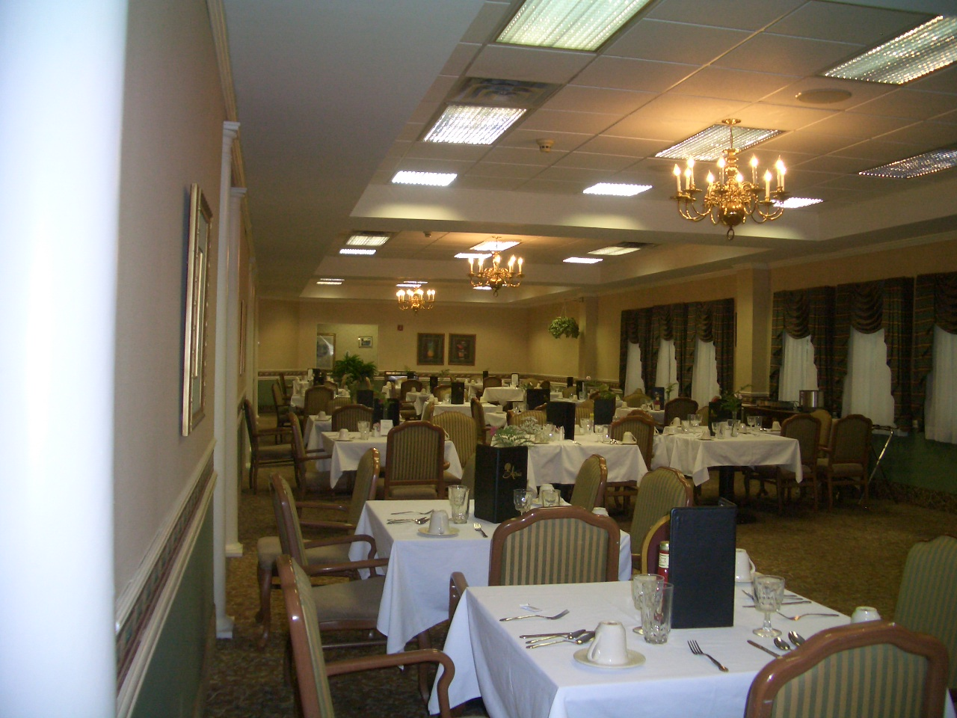

View of Dining Area

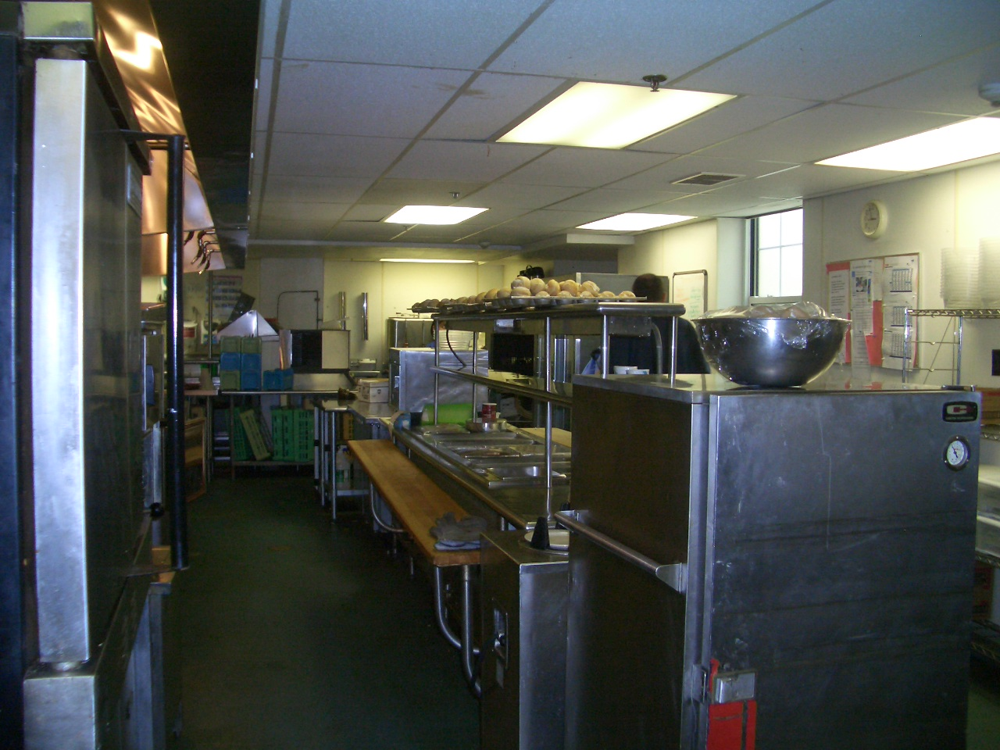

View of Kitchen Area
ADDITIONAL SUBJECT PHOTOGRAPHS

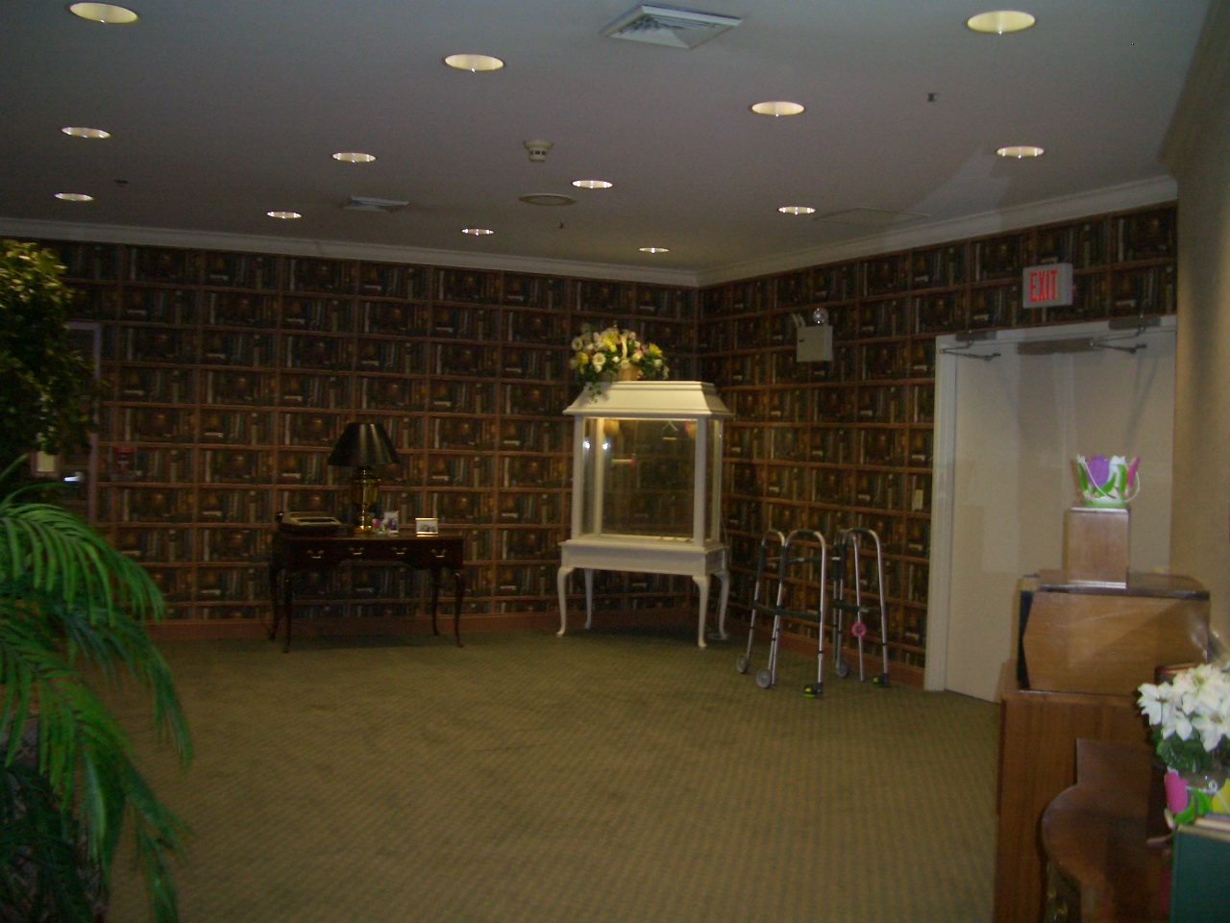

View of Library

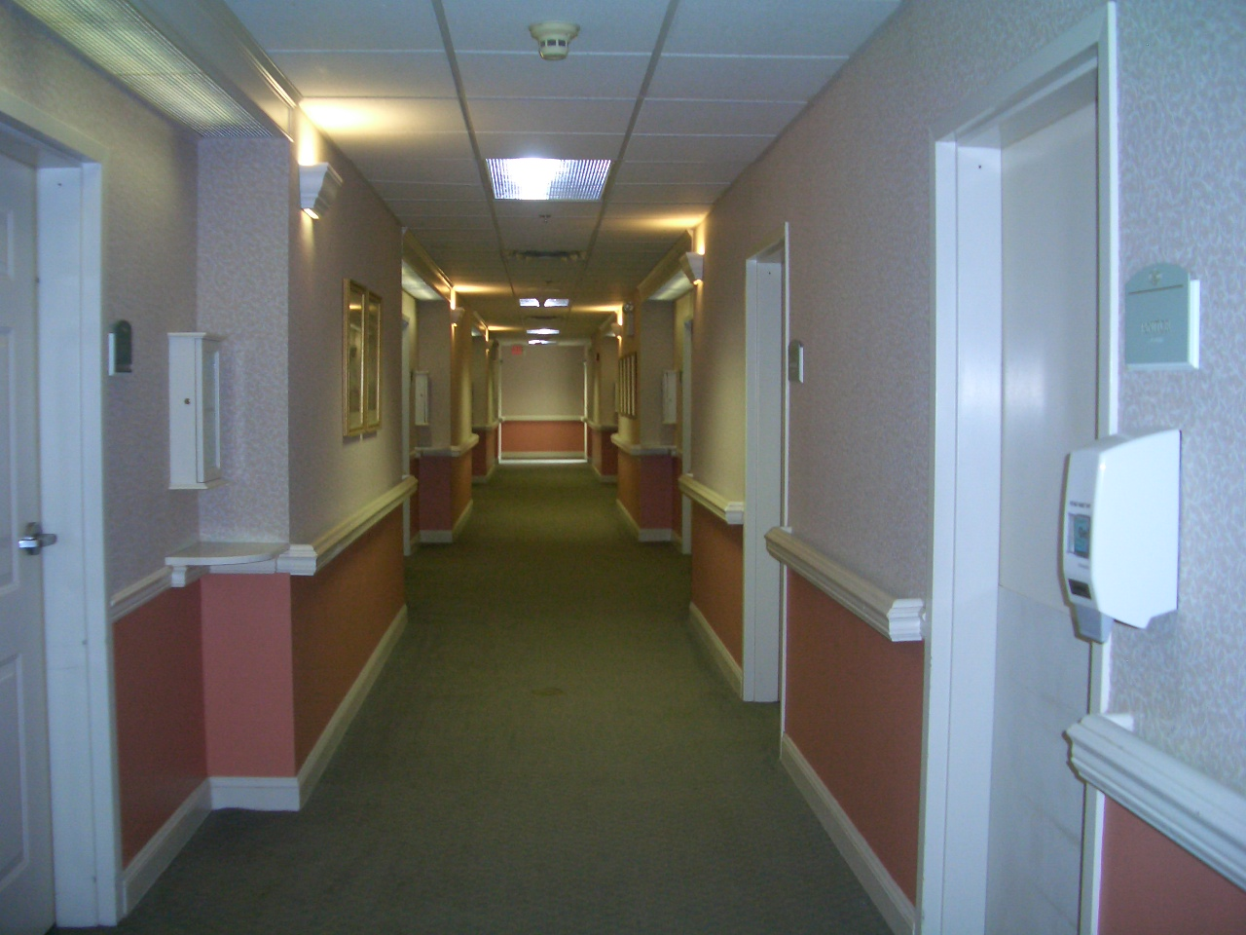

View of Typically Hallway
ADDITIONAL SUBJECT PHOTOGRAPHS

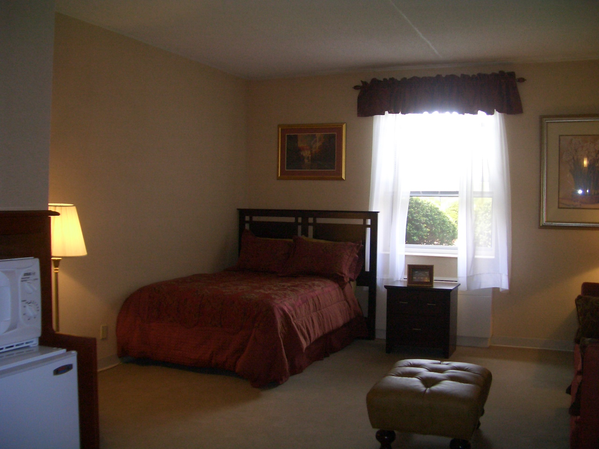

View of Typical Resident Unit

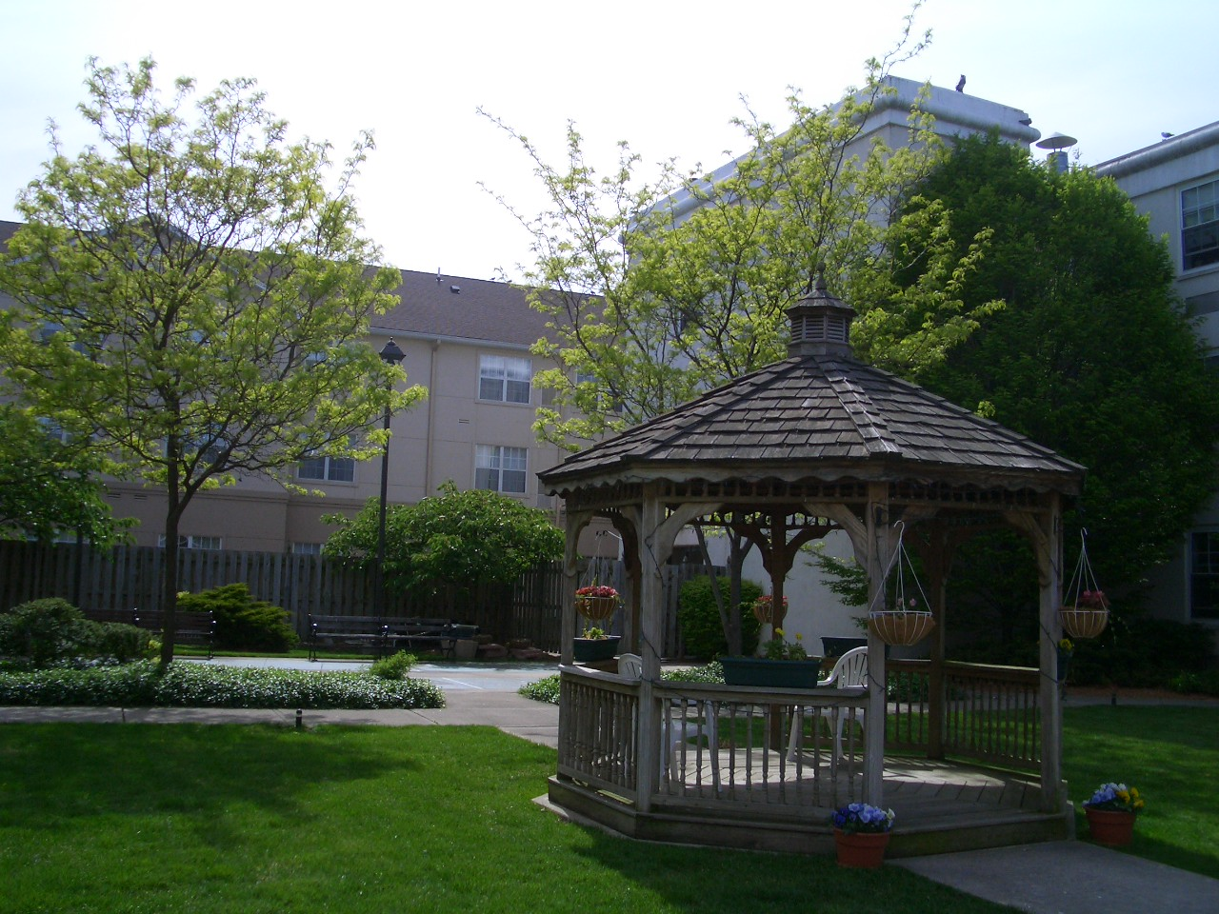

View of Outside Courtyard Area

The State of Senior Housing Data

American Council of Life Insurers

QUALIFICATIONS OF APPRAISERS
Qualifications - Joseph E. Baldoni, MAI

Business:
APPRAISAL ASSOCIATES, INC.
524 South Avenue East
Cranford, New Jersey 07016

Designations and Professional Affiliations:
• Designated Member, MAI, The Appraisal Institute (#5671) - Currently Certified
• State Certified General Real Estate Appraiser - New Jersey License No. RG 00339
• State Certified General Real Estate Appraiser - Pennsylvania License No. GA-001202-R
• Associate Member - Mortgage Bankers Association of New Jersey
• Licensed Real Estate Broker - State of New Jersey
• Member - Westfield Board of Realtors

Education:
• Attended Seton Hall University

• American Institute of Real Estate Appraisers:
Course I - Appraisal Theory and Practice (University of Connecticut)
Course II - Urban Properties (University of Connecticut)
Course VI - Investment Analysis
Course VII - Residential Appraising
Course - Real Estate Valuation in Litigation

• Graduate School of Michigan State University
Certificate in Advanced Income Property Valuation. Courses included Income Property Finance and Advanced Income Property Finance.

• Society of Real Estate Appraisers Report Writing Seminar (Hofstra University)

• Attended numerous lectures and seminars on real estate appraising, financing, construction techniques, construction cost, management and business valuations methods.

Lecturer and Expert Witness:
• Somerset County College - "Appraisal Techniques" - Guest Lecturer
• Glen Rock Community School - "Real Estate as an Investment" - Lecturer
• Accepted and testified as expert witness - Tax Courts of New Jersey and Missouri, Superior Court of New Jersey and Federal Bankruptcy Court.

Experience:
Present: President - Appraisal Associates, Inc., which is actively engaged in the appraising of all types of real estate for all purposes. Studies performed to determine projects' feasibility and viability, as well as highest and best use analyses and consultation on total real estate portfolios.

Qualifications -- Joseph E. Baldoni, MAI (Continued)

Experience:
Past: Vice President - Appraisal Department Manager and Chief Appraiser of International Appraisal Co., a nationwide appraisal company with emphasis on corporate appraisal needs.

Income Loan Originator - Jersey Mortgage Company. Main duties to originate, underwrite, appraise and negotiate loans on income-producing properties.

Associate Appraiser - Van Syckle Agency. Appraised all types of properties in New Jersey. Performed zoning studies and land utilization analyses.

Assistant Vice President - Porter Company, Ltd. Supervised appraisal staff in performance of appraisals for all purposes.

Appraisals of Special Note:
• 32-story luxury high-rise apartment complex
• 500,000 S/F industrial warehouse facility
• 470 unit proposed condominium project
• Alumina Refining Facility
• 2,400,000 S/F automobile assembly plant
• Hollywood film studio, sound stages and back lot
• Lumber and pulp mill facilities
• Proposed 690-room center city luxury hotel and 27-story office building
• Proposed multiple-building office park
• 2,600,000 S/F airline overhaul base
• 800 unit garden apartment complex
• Enclosed regional shopping malls

Prepared for:
• Acquisition and disposal
• Mortgage financing
• Tax appeals
• Condemnation proceedings
• Allocation of purchase price for Internal Revenue reporting
• Estate matters
• Partnership dissolution
• Investment tax credit analysis
• Component depreciation studies
• Land utilization and marketability studies
• Zoning analysis
Qualifications – Joseph C. Baldoni

Business:
APPRAISAL ASSOCIATES, INC.
524 South Avenue East
Cranford, NJ 07016

Designation and Professional Affiliations:
- State Certified General Real Estate Appraiser – New Jersey License No. RG 001977
- Associate Member of the Appraisal Institute
- Board of Directors Metro New Jersey Chapter of Appraisal Institute
- Communication and Technology Committee Member - Metro New Jersey Chapter of Appraisal Institute
- Fall Conference Committee Member – Metro New Jersey Chapter of Appraisal Institute

Education:
- Masters of Science in Real Estate – New York University, New York, NY
Graduated August 2003
- Bachelor of Science in Finance – University of Scranton, Scranton PA.
Graduated May 1999
- Appraisal Institute
Course 110 -- Appraisal Principles
Course 120 – Appraisal Procedures
Course 410 – Standards of Professional Practice, Part A

Present Experience:
Associate Appraiser – Appraisal Associates, Inc., which is actively engaged in the appraisal of all types of real estate for all purposes.

Past Experience:

American International Group (AIG), New York, New York (6/99-4/00)
Claims Analyst I – Fidelity Bonds Department
- Handled claims regarding employee dishonesty and financial institution fraud.
- In charge of the Visa account for credit card claims

Professional Associate (PA) – Fidelity Bonds Department (4-9/00)
- Worked on various assignments for the department
- Opened and closed claims
- Paid vendors and clients

Appraisal Associates, Inc., Cranford, New Jersey (Various Dates 1990-95)
PARTIAL LIST OF CLIENTS SERVED
(Served By The Firm Or Its Associates)

Corporate
Acco Corporation FMC Corporation Pfizer, Inc.
Alcan Aluminum Ford Motor Company Prentice Hall
Alcoa Aluminum Gannett, Inc. Qume Corporation
Allied Stores General Foods Corporation Rapid Industrial Plastics
Amicor, Inc. H. J. Heinz Corporation Red Roof Inn
American Cancer Society Honeywell Corporation Reynolds Metal Company
American Chromalloy Howard Johnson's Company Rockwell International
Amex Specialty Metals IBM Corporation Singer Company
A T & T Industrial Industries Sun Chemical
Bethlehem Steel Ingersoll Rand Corporation Toresco Enterprises
Borden's, Inc. ITT Corporation Transnet Corporation
Borg Warner Jones & Laughlin Steel T W A
Boyle Midway Corp. Kentucky Fried Chicken Uddeholm
Brick Church Appliances Keuffel & Esser Company United Technologies
Bucyrus – Erie Kinney Shoe Corporation Valcor Engineering
CBS, Inc. Kitty Kelly Company Vorelco, Inc
Cyclops Steel Kraft, Inc. W. W. Grainger, Inc.
Daido Corporation Lemar Apparel Group, Inc. Warner Lambert
Digital Equipment Corporation Martin Marietta Aluminum Westinghouse
Entenmann's Bakery Maxwell House Coffee White Chemical
Eastman Kodak Oscar Mayer Corporation William Steinen Mfg.
Fluid Packaging Corporation Otis Elevator

Banks and Financial Institutions
American Savings Bank East River Savings Bank Mortgage Personnel Services
Amerifederal Savings Eastern Savings Bank Mutual Benefit Life Insurance Bank of America E. B. Mortgage Corp. National Westminster Bank
Bank of India Equitable of Iowa New Brunswick Savings Bank
Bankers Life First Nat'l Bank of Central Jersey New England Mutual Life Ins.
Bell Savings Frank Holland Mortgage Co. New York Life Insurance Co.
Buchbinder-Silverstein & Solove Gibraltar Savings Bank New York Urban
C & C Income Property Services GMAC Mortgage Corp. Paine Webber Mtg. Financial
Carteret Savings Bank Harmonia Savings Bank Phoenix Mutual Life Ins,
Cenlar Capital Corporation Home Life Insurance Corp. Provident Mutual Life Ins.
Chemical Bank Howard Savings Bank Provident Savings Bank
Coldwell Banker Hudson United Bank Punia Mortgage Company
Colonial National Mortgage Irving Trust Company The Bank of Tokyo
Columbia Savings & Loan Larson Financial Resources, Inc. The Canada Life Assurance ComFed Realty Credit Co., Inc. Lehigh Financial Corp. The Greater New York
ComFed Savings Bank Maplewood Bank and Trust Co. Saving Bank
Commonwealth Eastern Mtg. Corp. Meritor Credit Corp. The Summit Trust Co.
Crestmont Federal Savings & Loan Metropolitan Life Insurance Union Carbide Pension
DRG Financial Corp. Morris County Savings Bank Union County Savings Bank
East Bank Morsemere Federal Savings and Loan

Builders / Developers / Investors
Adian Corporation Hartz Mountain Industries, Inc. Metropolitan Properties
American Management HOWCO Company Murray Construction Co.
Bellemead Development Corp. Jos. L. Muscarelle, Inc. Oldnick & Fischer Develop
Briar Hill Construction Kenbee Management Company Oxford Properties, Inc.
Dowell Associates, Inc. Kent Associates Palm Development Group
East Meadow Corporation Klein Industries, Inc. Pond View Associates
Equity Restorations Krantz & Son Realty Rotwein & Blake
Evans Partnership Krupp Bros. Summit Associates, Inc.
Fairchild Equity Corporation Lan Associates William Krupp
Fox Financial LCL Equities
Garibaldi Realty M. Alfieri Company

Others
Borough of Montvale Government Service Administration Township of Cranford
Cranbury Township The Trust for Public Lands Washington Township

The Appraisal Institute, The Appraisal of Real Estate, c. 2001, Twelve Edition, p. 23
Department of Health and Services, State of New Jersey, www.state.nj.us/health/ltc/
The Appraisal Institute, The Appraisal of Real Estate, c. 2001, Twelve Edition, p 305.
The Appraisal Institute, Hotels and Motels, c. 2001, p 361
IBID p. 360.

